Banyule City Council

Urban Food Strategy

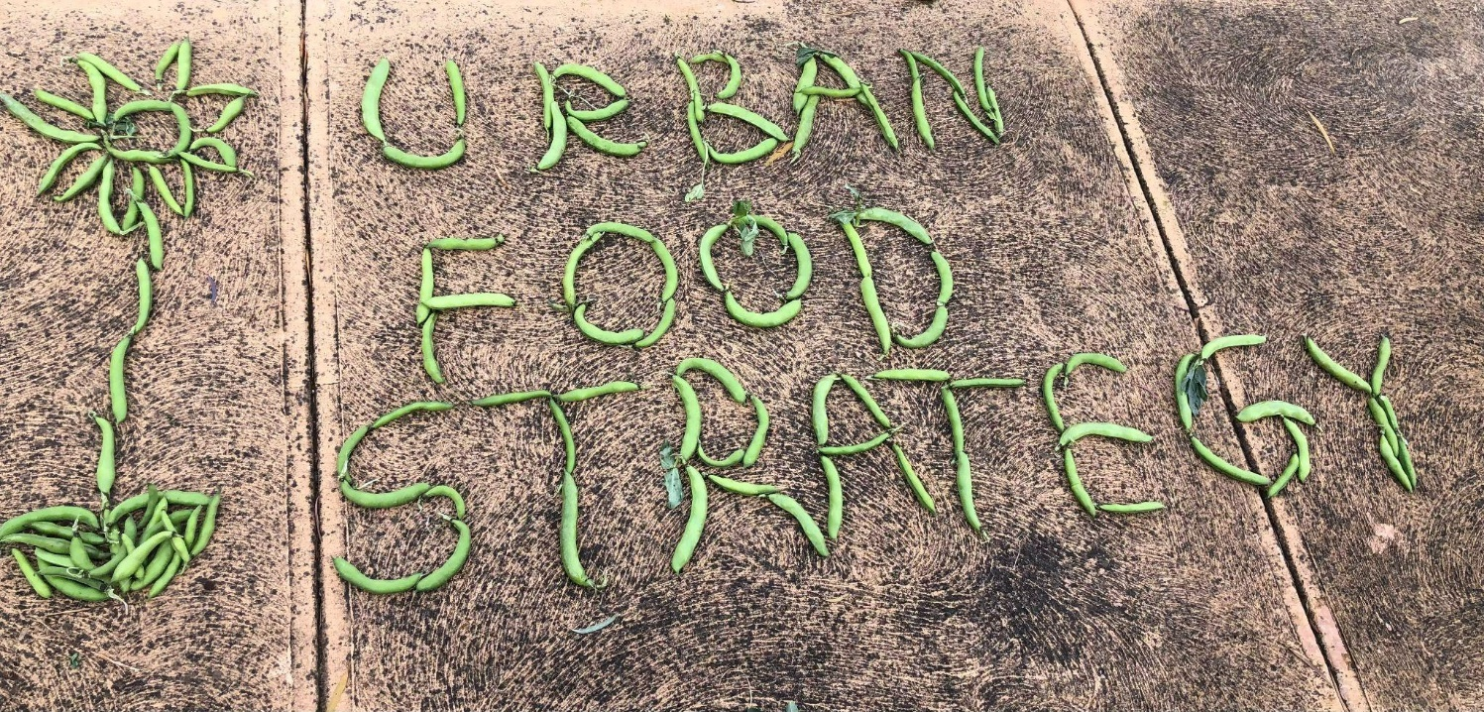
Consultation Report

Prepared by:
Dr Nick Rose
Dr Kelly Donati
Sophie Jamieson
Beth Ciesielski
Carol Perdigão

Acknowledgement of Traditional Custodians
Sustain: the Australian Food Network and Banyule City Council proudly acknowledge the Wurundjeri Woi-wurrung people as the Traditional Custodians of the land which Council operates on. We pay our respect to all Aboriginal and Torres Strait Islander Elders, past, present and emerging, who have resided in the area and have been an integral part of the region’s history.

Banyule’s Diversity Statement
Our community is made up of diverse cultures, beliefs, abilities, bodies, sexualities, ages and genders. We are committed to access, equity, participation and rights for everyone: principles which empower, foster harmony and increase the wellbeing of an inclusive community.

Acknowledgement of consultation participants
Sustain and Banyule City Council would like to acknowledge the individuals, businesses and organisations who dedicated their time and contributed their input to this consultation report via focus groups, surveys, pop-up sessions, kitchen table talks and a community workshop. We would like to acknowledge the contributions of many Banyule Council staff who engaged directly with the consultation process and shared their expertise. We extend our deepest appreciation to members of the Urban Food Strategy Working Group who generously supported the consultation process with their time, ideas and networks.
Banyule City Council is made stronger by the collective expertise, ideas, enthusiasm and passion of the many people, organisations and businesses committed to an inclusive, healthy, sustainable and delicious food future for the whole community.

Community recipes by Aunty Jenny

Special zucchini pie
Heat oven to 180 degrees Celsius.
Cut crusts off soft old bread.
Butter bread inside and outside with butter or margarine.
Put bread in tray in similar way to pastry, squish down to make sure you’ve formed a good crust.
Cook diced bacon and let the oil drain out.
While waiting for bacon to cool, grate four zucchinis and squeeze out water.
In a bowl, mix grated zucchini, bacon, six eggs and your choice of seasoning (suggested chicken salt).
Put wet mixture into bread lined tin, and cover with grated cheese.
Put into oven until cooked (around 30 minutes).

Silverbeet burritos
Cook silverbeet leaves for five minutes in water to blanch, strain out water and put leaves aside.
Cook pumpkin until just soft to turn into a creamy mash.
Cook beef mince with carrot, onion, and seasoning of choice.
Spread mashed pumpkin over laid-out silverbeet leaves, cover with a bit of beef mince and wrap into a burrito.
Repeat for all leaves and mixture.
Put in oven for 20 minutes or until warm.

We thank the staff and volunteers at Barrbunin Beek for sharing their time and insights, in particularly to Aunty Jenny who generously shared her recipes.
Table of Contents

Acknowledgements 2
Community recipes by Aunty Jenny 3
Executive summary 5
1. Introduction and overview 6
2. Engagement, participation and methodology 8
3. The community’s aspirations for Banyule’s food system 9
4. Strategic policy and program alignment with food system themes 12
5. Common elements in best-practice in food system strategy 14
6. The big picture: suburban sprawl, climate change and Melbourne’s foodbowl 16
7. Key findings: an analysis of Banyule’s food system 17
Strengths 17
Critical issues and emerging vulnerabilities 24
8. Opportunities, community priorities and recommendations 42
Theme 1 - An inclusive and connected food community 42
Theme 2 - A thriving local food economy 44
Theme 3 - Planning for healthy and sustainable food environments 46
Theme 4 - Abundant edible landscapes 50
Theme 5 - Good food system governance 56
Appendices 59
Appendix A: Methodology: summary of consultation activities and participation 59
Appendix B: Definitions and Terminology 64
Appendix C: Strategic context: policy analysis and mapping 66
Appendix D: Urban Food Strategy Working Group 73
References 75

Executive summary
From October to December 2022, over 600 Banyule residents and council staff shared their views on the Urban Food Strategy through a mix of community engagement methods. Combined with desktop research and food system mapping, several key findings emerged together with five themes that can guide the Strategy’s development. The overall message is that this Strategy is warmly welcomed by residents and staff, with much anticipation and enthusiasm about what can be achieved through its implementation.
Key findings
- Food insecurity and economic precarity are rising: a concerning one in five community survey respondents reported some level of food insecurity in the last year
- The local food economy is contracting: Local food and beverage sales fell by 15% from 2016 to 2021, and employment in this sector declined by 16% in the same period
- Banyule has many strengths and opportunities: a highly motivated and capable community of food organisations and individuals; an emerging network of innovative social enterprises and urban farms; enormous economic development potential with the La Trobe National Employment and Innovation Cluster; and strong alignment across many existing and emerging Council strategies and plans
Key themes
Priority themes for the Urban Food Strategy
Theme 1: An inclusive & connected food community | Theme 2: A thriving local food economy
Theme 3: Planning for healthy and sustainable food environments | Theme 4: Abundant edible landscapes
Theme 5: Good urban food system governance
Key recommendations for the Strategy’s development
- Clearly articulate the role of Council, community and other partners
- Ensure alignment with key strategic policies and priorities
- Set clear, achievable and measurable targets, measures and indicators
- Ensure the Strategy is accompanied by a robust communications plan
- Ensure the Strategy is adequately resourced for effective implementation

Introduction and overview

Background
Banyule is a diverse community, with varying levels of access to and participation in the urban food system. COVID-19 increased reliance on emergency food relief, particularly amongst vulnerable population cohorts highlighting social inequalities. In 2022, cost of living pressures (price inflation of many necessities, including food, as well as several interest rate rises and associated increases in mortgage payments and rents) saw more residents become vulnerable to food insecurity, including working families. More broadly, urbanisation, changing food consumption behaviour patterns and climate change impacts have a direct correlation to vulnerabilities in Banyule’s urban food system.
In response to these serious challenges, in August 2022 Banyule City Council engaged Sustain: the Australian Food Network to facilitate the development of an Urban Food Strategy. This process was grounded in the values of social justice and based on a participatory and inclusive approach to community engagement, in order to create and strengthen a sustainable, healthy, local, and accessible food system for all.

Purpose of the Urban Food Strategy
The Strategy presents an opportunity for strategic and systematic impact, recognising Banyule City Council as a leader in food security and urban food initiatives. Accordingly, the Strategy’s development will address and facilitate the relationships between urban food systems and health and wellbeing, as well as economic, environment and planning development and outcomes. The purpose of the Urban Food Strategy is therefore to provide a framework for supporting a strong urban food system that generates equitable health and wellbeing, economic, and environmental outcomes for the Banyule community.
The Urban Food Strategy will position Banyule City Council to better respond to vulnerabilities in the urban food system, as well as enhance Council and community resilience to meet current and emerging challenges. It will enable Council to pursue collaborative partnerships with key stakeholders in attracting opportunities for funding, projects and advocacy to enhance Banyule’s urban food system.

About this report
This consultation report summarises background research, extensive stakeholder engagement and community consultation undertaken by the Sustain team, with support from Banyule City Council, from September to December 2022. The consultation process and methods are summarised in Appendix A. This report provides the foundation for the subsequent drafting of the Urban Food Strategy, to take place in February and March 2022. This report identifies strengths and vulnerabilities of Banyule’s urban food system and highlights opportunities, emerging concerns and focus areas for future action.
This consultation report is committed to reflecting the diverse perspectives of the Banyule community. Coloured text boxes entitled “community voice” highlight what residents, Council staff and people working within Banyule shared regarding their vision and priorities for the Banyule urban food system. Key definitions and terminology regarding the food system are provided in Appendix B.

Community expectations for the role of Council
Community’s expectations of Council regarding the Urban Food Strategy can be synthesised as follows:
- Develop a vision the whole community can support
- Connect people across the food system (for service delivery, business needs and making the community aware about how they can access emergency food relief)
- Provide opportunities to build relationships so that community members can support each other and share resources
- Provide assistance to cut through red tape, find land and navigate council policies
- Facilitate and lead community food events
- Provide funding to enable urban food projects

Community voice
“Sporting clubs get lots of money, but food systems don’t. Prioritise and recognise it as a community asset and something for the future.”  – Heidelberg resident (kitchen table talk) | “A strategy about food will include climate change, wellbeing and connecting the lonely people in the community. It will be about sharing, heritage and culture – a unifying factor for a fragmented world.”  – Montmorency resident (kitchen table talk)

Engagement, participation and methodology
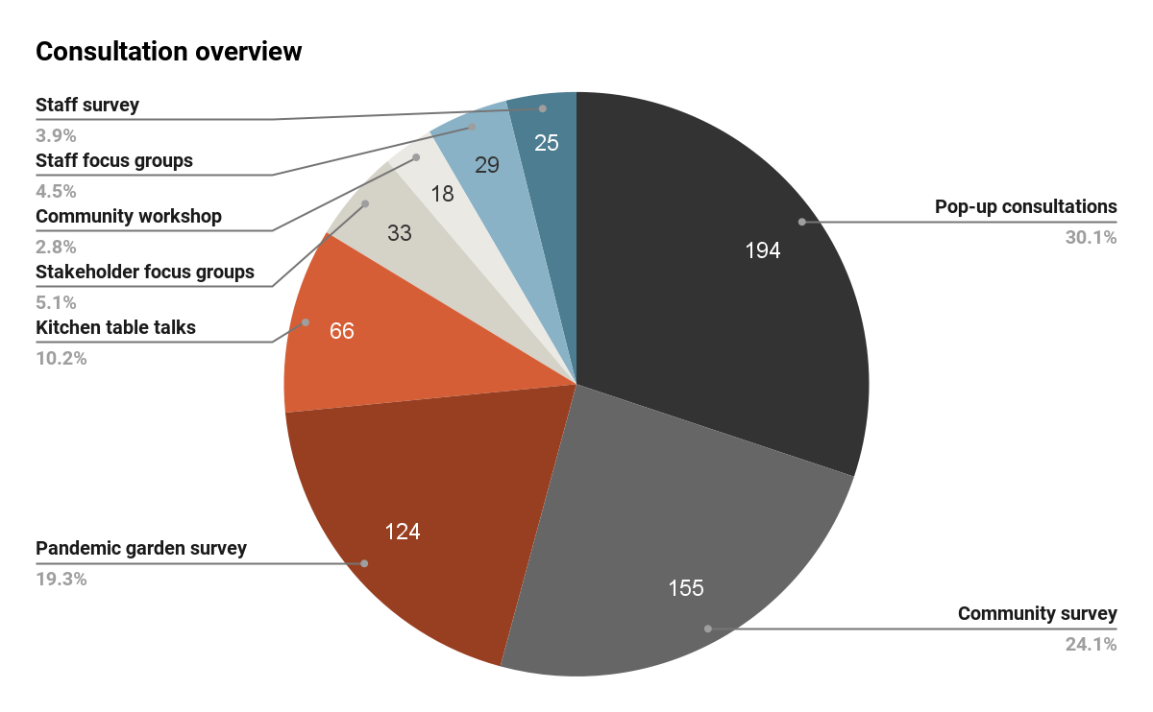
The development of this consultation report commenced through a process of desktop research, food system mapping and analysis of relevant local, national and international policies (detailed in Appendix A). This background research helped to inform the development of a holistic, multi-dimensional and robust consultation process to understand aspirations and priorities for Banyule’s urban food system from key stakeholders and the broader Banyule community (Figure 1).
Figure 1

Community voice
“This is a perfect first step to launch a collaborative approach to growing and distribution in Banyule and surrounding LGAs.”  – Works in Banyule (community survey) | "I’m just impressed that Council is going down this road [of community consultation] and hope this really turns into something."  – Ivanhoe resident (kitchen table talk)

The community’s aspirations for Banyule’s food system
Banyule Community Vision 2041
“We in Banyule are a thriving, sustainable, inclusive and connected community. We are engaged. We belong and we value and protect our environment.”
Priority themes
- Inclusive and connected community
- Sustainable environment
- Well-built city
- Valued community assets and facilities
- Thriving local economy
- Trusted and responsive leadership

Banyule Community Vision 2041
The Banyule Community Vision 2041, which captures the community’s aspirations for the future of Banyule, informed the desktop research and consultation process. Its priority themes provided the backbone for the development of the five priority themes for Banyule’s urban food system.

Community vision for Banyule’s food system
Drawing on the six themes of the Banyule Community Vision 2041, we developed the following community vision for Banyule’s urban food system (Figure 2).
“Banyule’s urban food system provides equitable access to fresh, healthy, local and culturally appropriate food for all residents. We feel connected to its abundant edible landscapes and our thriving local food economy. Inclusiveness, collaboration and participatory decision-making guides our collective path to a healthy and sustainable food future.”
Community voice
“My vision is for a food-connected community where food and food products are the centrepiece of a table shared by residents who are diverse yet bonded by a common love of good, healthy food and food practices. For this to happen, food needs to be locally visible, poking out of every nook and cranny – present everywhere there are people: meals gracing outdoor dining parklets, corner cafes, street festas and carpark markets. This is food richness, vibrancy and the stuff of living well.” – Ivanhoe resident (community survey)

Priority themes for the Urban Food Strategy
Theme 1: An inclusive, connected food community  All Banyule residents have equitable access to fresh, healthy and culturally appropriate food. Community food relief initiatives, where required, put people’s dignity first. Food is the connective tissue of Banyule’s diverse communities, bringing people together to celebrate and share their food cultures, knowledge and skills. | Theme 2: A thriving local food economy  Local neighbourhoods have a lively, village feel, and local food businesses reflect the cultural diversity of their communities. Banyule residents find it easy and convenient to buy good food locally. Greengrocers, butchers, bakers and other food businesses provide job opportunities and cater to people visiting, working or living in the municipality.
Theme 3: Planning for healthy and sustainable food environments  The food system is understood as vital urban infrastructure, and access to healthy, affordable and sustainable food contributes to a sense of place, creates a sense of belonging and underpins neighbourhood and precinct planning. Healthy and sustainable food environments are not left to chance but rather integrated into the local planning scheme. | Theme 4: Abundant edible landscapes  Food is grown in backyards, community gardens and other spaces across the municipality. Urban farmers are supported to grow food and feed their community. Community members can access information and a wide array of educational and skills building activities about growing food, and there is a strong network of food gardeners.
Theme 5: Good food system governance
The governance of Banyule’s food system is consultative, collaborative and participatory. Strong leadership support for the Urban Food Strategy within Council is strengthened by a diverse and lively network of urban farmers, community gardeners, local business owners, community organisations and their volunteers along with neighbourhood house and community centre staff, teachers and students. Together they can each play a role in urban food system decision-making by the enabling frameworks established and maintained by Banyule City Council. The ‘food lens’ is applied to the development of new or review of existing relevant policies, strategies and plans to ensure strategic alignment and policy integration across Council.

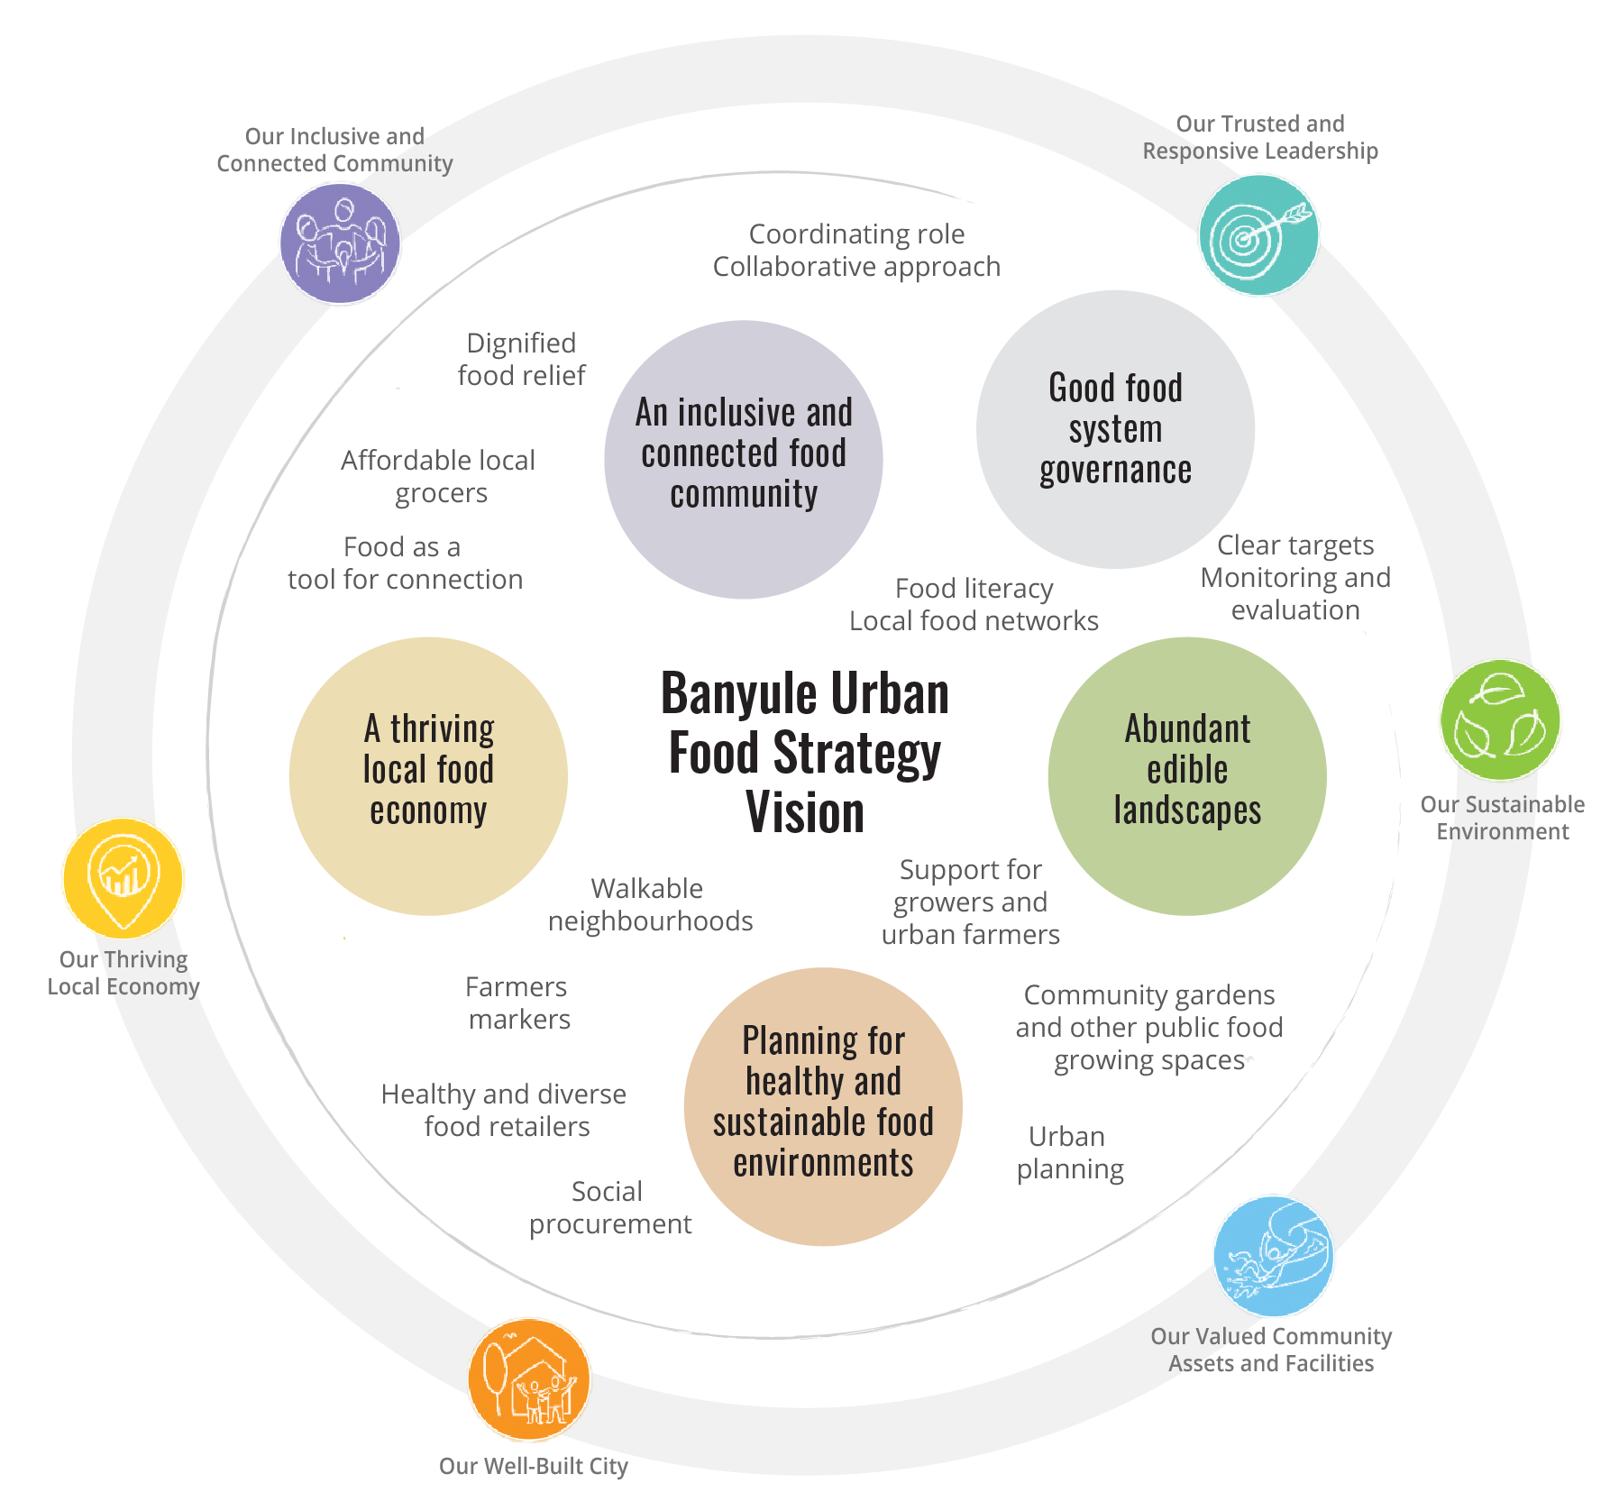
Figure 2

4. Strategic policy and program alignment with food system themes
The broader strategic context was considered in reviewing the Council strategies and plans relevant to the development of the Urban Food Strategy (Figure 3). The extent of this alignment reflects the systemic and cross-cutting nature of food systems, including economy, health and wellbeing, environment and planning.
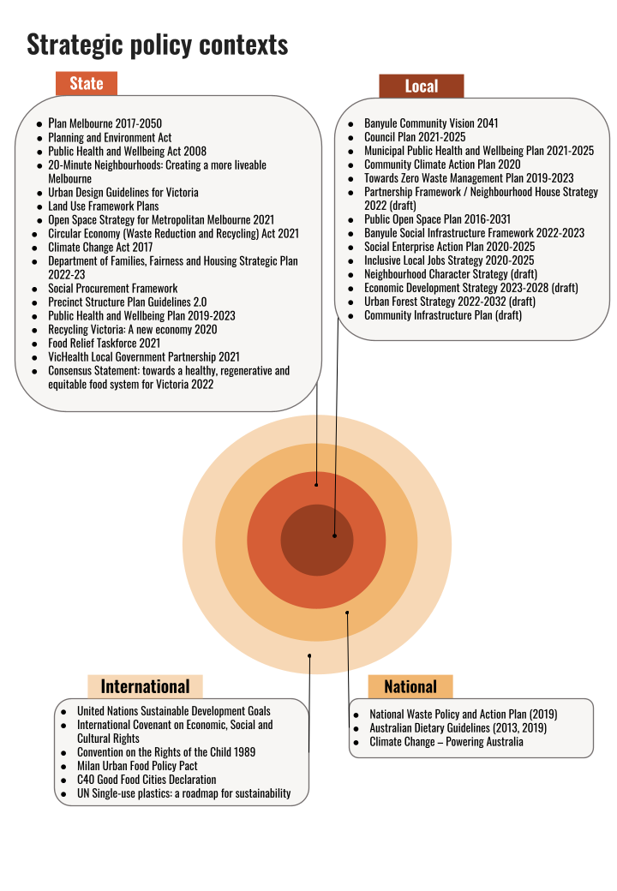
Consultation with senior Banyule managers highlights strong alignment between the emerging vision, key themes and priorities for the Urban Food Strategy with existing policies and plans as well as strategies currently under development or scoped for review. This includes Council’s priorities and goals regarding economic development (e.g. strategies such Inclusive Local Jobs and the Social Enterprise Action Plan), climate change and sustainability (including the urban forest canopy and waste minimisation), neighbourhood character and amenity, health and wellbeing (dietary, physical and mental), open space liveability and accessibility to basic daily necessities.
Figure 3

Alignments between key themes for the urban food strategy and key council policies and strategic priorities are summarised in the table below. The Banyule Community Vision 2041 and Council Plan 2021-2025 cuts across all themes (see Appendix C for detailed analysis).
Urban Food Strategy - key themes | Opportunities for strategic and policy alignment
Theme 1  An inclusive and connected community | Municipal Public Health and Wellbeing Plan 2021-2025  Partnership Framework / Neighbourhood House Strategy 2022  Arts and Culture Strategic Plan  Older Adults Strategic Plan  Community Engagement Policy  Neighbourhood Character Strategy (draft)  Community Infrastructure Plan 2023-2033 (draft)
Theme 2  A thriving local food economy | Community Climate Action Plan 2020  Economic Development Strategy 2023-2028  Social Enterprise Action Plan 2020-2025  Banyule Inclusive Local Jobs Strategy 2020-2025  Neighbourhood Character Strategy (draft)
Theme 3  Planning for healthy and sustainable food environments | Banyule Planning Scheme  Walking Strategy 2018-2028  Zero Waste Management Plan 2019-2023 (due for review)  Community Climate Action Plan 2020  Banyule Inclusive Local Jobs Strategy 2020-2025  Banyule Social Infrastructure Framework 2022-2023 (due for review)  Urban Forest Strategy (draft)  Neighbourhood Character Strategy (draft)
Theme 4  Abundant edible landscapes | Municipal Public Health and Wellbeing Plan 2021-2025  Partnership Framework / Neighbourhood House Strategy 2022  Public Open Space Plan 2016-2031  Banyule Social Infrastructure Framework 2022-2023  Biodiversity Plan 2019-2022  Community Climate Action Plan 2020  Neighbourhood Character Strategy (draft)  Urban Forest Strategy (draft)  Community Infrastructure Plan 2023-2033 (draft)
Theme 5  Good food system governance | Community Engagement Policy

5. Common elements in best-practice in food system strategy
While there is considerable variation in food system strategies in local governments in Australia and internationally, the following common elements have been identified in the literature as critically important enablers for effective food system change:
- Leadership and organisational commitment: Strong support from the senior management team and elected representatives is a common factor for leading practice. This in turn fosters and enables passionate and values-driven staff who are committed to achieving the successful implementation of the food policy (Coulson and Sonnino, 2019; Davies, 2018; Carrad et al., 2022a).
- Partnerships and collaborative governance: Changing the food system can’t be achieved by local governments alone. Collaborative governance mechanisms involving diverse actors invariably feature as a core element of leading national and international practice (Barbour et al., 2022).
- Policy integration and coherence: The food system impacts (and is impacted by) multiple policy domains including climate change, health and wellbeing, economic development, and strategic planning. Best-practice food policies ensure that they do not become siloed within the organisation, but rather seek alignment, synergies and coherence (Carrad et al., 2022b).
- Focus on systemic issues: The effectiveness of food policy action is limited when the focus is primarily on individual behavioural and consumption decisions. However, system issues are often neglected. An analysis of 23 nutrition policies in 19 high-income countries found no examples of ‘the multi-strategy, inter-sectoral, coordinated, evidence-based policies required to drive systemic transformation’, such as fiscal and regulatory measures to combat the power and influence of unhealthy food and beverage industries (Lee et al., 2021).
- Adequate and sustained resourcing: Changing the food system is a long-term process that takes perseverance, as well as adequate resourcing both internally and externally (Slade and Baldwin, 2017). World leaders recognise this and have been investing in food system change for over 30 years (Carrad et al., 2022a).
- Effective policy communication: While it is a truism that food affects everyone, understanding of what the food system is and its impacts on individuals, cities and ecosystems (what is termed ‘food systems literacy’) is not widespread. Leading cities internationally engage in sustained communication of their food policies and associated initiatives, both internally and with external stakeholders and experts as well as the general public.
- Active and engaged citizenry: There are limits to the power of local governments to bring about necessary food system change, especially in Australia. A mobilised and active citizenry is vital to work with councils to advocate for legislative and regulatory reform at the state and federal levels to make structural shifts in food system dynamics (Rose and Lourival, 2019; Swinburn et al., 2015).
- Strong data collection and monitoring: Making the case for needed reforms requires compelling evidence. Systematic data collection showing impacts of food policy implementation also consolidates commitment across the organisation, as well as amongst partners, for the shared agenda and goals that underpin food policy (Leeuwis et al., 2021; Sibbing et al., 2022).

6. The big picture: suburban sprawl, climate change and Melbourne’s foodbowl
Melbourne is a sprawling city and has lost much of its most productive peri-urban farmland. On the current trajectory of population growth combined with loss of farmland, Melbourne’s productive capacity will reduce by over 50% in the next 25 years in the absence of clear planning controls and prioritisation of vital farmland areas over new suburban developments. Melbourne’s foodbowl regions (Werribee South, Casey-Cardinia, Yarra Valley and Mornington Peninsula) have come under increasing development pressures as the city’s population has expanded rapidly in recent decades (Sheridan et al., 2016; see other Foodprint Melbourne reports). Combined with the anticipated impacts of climate change and extreme weather events, this dynamic is a serious threat to future food security facing the broader Victorian community.
The pandemic also revealed the vulnerability of mainstream supply chains. Shorter supply chains, enabled by urban agriculture and local food systems, were less impacted by transport issues and labour shortages (Carey et al., 2021). This is consistent with previous supply chain disruptions, such as the Queensland floods (Smith and Lawrence, 2018). In the context of climate change, supply chain disruptions and increasing costs of agricultural inputs, it makes sense for local and state governments alike to support and invest in shorter, more resilient food systems.
The consultation process revealed that people living and working in Banyule are aware of and engaged in these issues. There is a strong desire to support local growers, to take action on climate change and to create a more equitable, connected community. Top priorities amongst community members and council staff are below.
Top priorities for the Urban Food Strategy
Community  (‘What would you like to see more of in Banyule?’) | Council staff  (‘What do you feel should be the top three priorities for Council in developing its Urban Food Strategy?’)
Local food access | Food relief and food security
Community food initiatives  (e.g. food swaps, pop-up markets, etc) | Sustainability and climate change
Community food growing | Health and wellbeing
Sustainable farming in & around Banyule

7. Key findings: an analysis of Banyule’s food system
The following section details a number of key strengths and emerging vulnerabilities, both internal and external to Banyule, which emerged from a mapping and audit of the Banyule food system, desktop research and community and stakeholder consultation.

Strengths

A strong, engaged community

The consultation process and desktop research reveal that a major strength of Banyule’s urban food system is its people: a network of knowledgeable and passionate food leaders, educators and volunteers who are keen to connect, open to collaboration and committed to their communities. They also are clearly seeking greater access to healthy, affordable and locally produced food and food products, which is a significant opportunity for urban farms and urban food enterprises.
Primary school students at St Pius X Primary School (Heidelberg West) were proud of their food literacy and were familiar with climate change, biology and farming. They enjoy participating in shopping, food gardening and cooking activities at home as well as appreciate diversity in their diet. This highlights the opportunities that engaging young people in gardening, cooking and eating activities at an early age present for ensuring the next generation is empowered to enjoy healthy eating practices.

Youth voice
“I haven’t had chicken nuggets for ages…. My mum is a great cook.” – Year 4/5 student (pop-up consultation) | “I cook lots of things by myself: omelettes and everything.” – Year 4/5 student (pop-up consultation)

Connected, engaged Council staff
Most Council employees feel engaged with the Banyule community in their current role (Figure 4). Many staff are interested in food systems issues and see clear synergies between their own work and the Urban Food Strategy. Many also grow their own food and share the value the community places on creating more edible communities (Figure 5). These synergies provide a strong foundation for good food system governance and an integrated approach to the implementation of the urban food strategy.
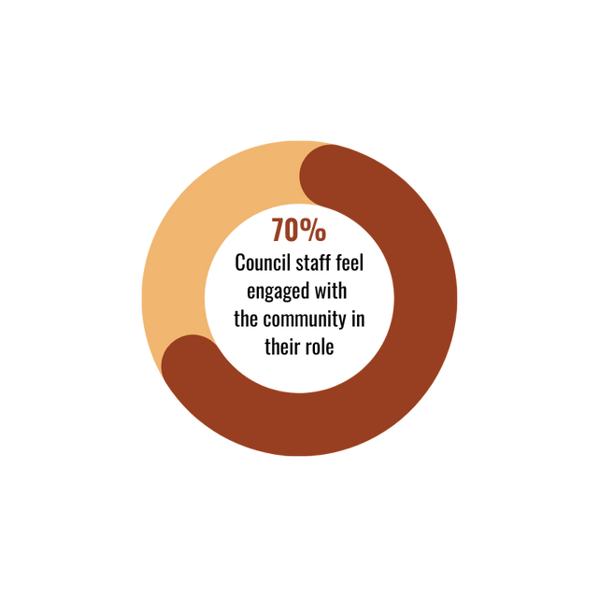
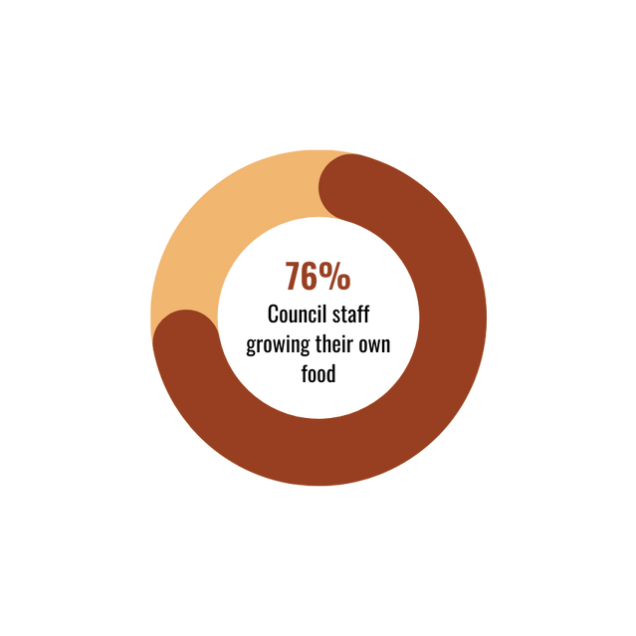
Figure 4
(staff survey)
Figure 5
(staff survey)

Council staff voice
“I truly believe that local food production is such a critical component of increasing our community's liveability.”
– Council employee (staff survey)

Strong alignment with existing and emerging strategies and priorities for Council
As noted earlier, there is strong strategic and policy alignment between the themes of the Urban Food Strategy, the six pillars of the Community Vision in Inclusive Banyule 2041 and numerous other strategies, policies and plans. The Inclusive Local Jobs Strategy and Action Plan (2020-2025) strongly reinforces and supports the theme for a thriving local food economy (theme 2), as does the new Economic Development Strategy, set for endorsement in 2023. Multiple strategies and plans align with community aspirations for more edible landscapes, as well as healthier and more sustainable food environments closer to home (themes 3 and 4). These include the Open Space Plan, Community Climate Action Plan, Neighbourhood Character Strategy and Urban Forest Strategy.

Strong, established local food and sustainability networks
These networks include Local Food Connect, Sustainable Macleod and the Teachers Environment Network (TEN). The Local Food Connect website and associated newsletter promotes many aspects of local food around northeast Melbourne including food-related events, food producers, food justice organisations, gardens and food swaps. The website also has a local food directory for over 300 local food organisations. Sustainable Macleod is part of the global Transition Towns movement and has supported a successful vegie swap and the Macleod Organic Community Garden. The TEN, co-ordinated by Banyule and Nillumbik Councils, provides valuable professional development opportunities in sustainability and environment areas for teachers. There are opportunities to build more food content within TEN activities and connect teachers to local community gardens. With support from Council these networks can grow and include communities of practice, providing in-person platforms to collaborate, reduce duplication of work, build a shared sense of ownership over the food system, and share knowledge and resources.

Existing initiatives: environment grant scheme
Council’s environment grants are highly valued by the community and have been a very popular Council resource for funding community garden projects, particularly the purchase of tools. Seventeen of 66 grant recipients from 2018 to 2022 were for urban food projects. Grant funding since 2018 (including this financial year) currently totals over $95,000. St John's Riverside Community Garden (Heidelberg) received $5,000 to expand their community garden in response to increased demand during and following the COVID-19 pandemic. This financial year, Buna Reserve Community Garden (West Heidelberg) situated near the public housing estate received a $10,000 grant to acquire and install a polytunnel and watering system and portable toilet and support community activities. The eligibility of urban farming and community gardens for the Environment Grants issued by Council should be retained. At this stage, these grants are effective in supporting community gardening projects, but a separate grants scheme could be considered to support other community food initiatives.

Major new economic development initiatives
The La Trobe National Employment and Innovation Cluster (NEIC) is one of seven clusters under development over the next decade to ‘support the projected significant employment and residential growth in Melbourne’s North’, including Banyule. La Trobe’s University City of the Future is projected to create over 20,000 new jobs at its Bundoora campus, additional housing for 12,000 students, staff and residents, learning and research facilities for 40,000 students, and contribute $3.5 billion in Gross Regional Product over the next decade. A major focus of the campus will be agriculture, food and the environment, as well as sustainable energy and sustainable transport. The public, private and university partnerships involved in this major strategic investment are significant. There is an early opportunity to connect the master planning process of the Heidelberg West Business Park with the NEIC, as it falls within the NEIC area and is already home to over 600 businesses, including nearly two dozen food and beverage enterprises.

Barrbunin Beek
Barrbunin Beek, meaning ‘happy place’ in the Woiwurrung language, is a space for the local Aboriginal and Torres Strait Islander community to come together. A dedicated men’s group, women’s group and Elders’ group provides an opportunity to celebrate and share knowledge and culture with a sense of community ownership. The food hampers provided to First Nations visitors at Barrbunin Beek on Fridays are much appreciated as are the hot breakfasts that provide an opportunity for people to gather around a shared meal.

Community voice
“Nothing goes to waste from my food boxes I get from here. I cook a lot of it and freeze it all so it doesn’t get wasted.” – Barrbunin Beek client (pop-up consultation)

Community food assets
Banyule City Council has a diverse range of community food assets. It is home to the innovative urban farming social enterprise, Farm Raiser in Bellfield (see case study box on page 22), as well as Veggie Empire’s Beales Road Farm in Greensborough. Community survey respondents appreciated the value these urban farmers bring to the community, not only in terms of access to fresh produce but for its strong youth leadership and their contribution to local sustainability and social justice. There was strong community support for more urban farms. A mapping of the local food system reveals a wealth of community food assets within Banyule and its immediate surrounding area (Map 1), including seed libraries, community gardens, social enterprise cafes, urban food producers, local food manufacturers and artisans. This map does not include cafes or greengrocers.

Community voice
“FarmRaiser is a fabulous example of urban spaces becoming one for local fresh food production and community. I want to see more of this.” – Ivanhoe East resident (community survey)
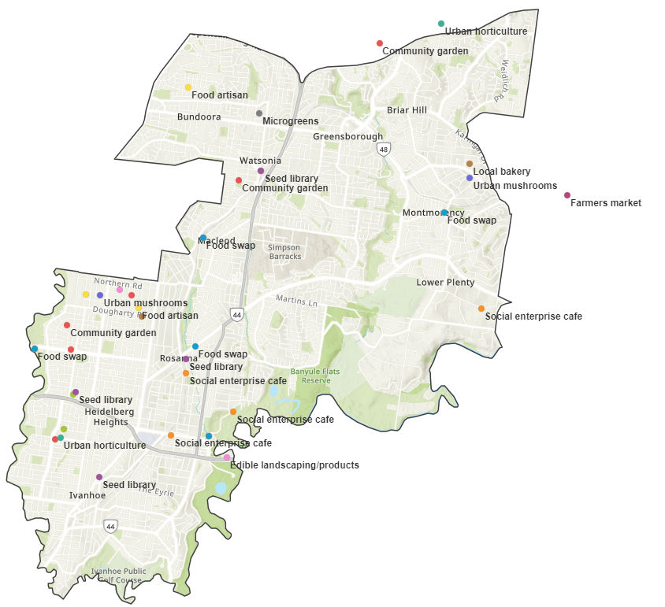
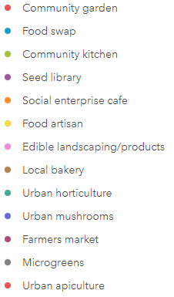
Map 1 – Banyule community food system assets

Note: this map is indicative only and may not represent all community food assets in Banyule. Activities or sites located at the same address (e.g. community gardens and food swaps) will appear as a single point on the map.

Case study – Farm Raiser
Farm Raiser is a registered charity running an urban farm in Bellfield, Melbourne. Established by three young farmers, they sell produce to the local community grown on land provided by Waratah Special Development School, connecting farming activities with educational opportunities for students. The purchase of critical infrastructure such as irrigation and polytunnels to establish the farm was made possible via seed funding from Banyule City Council and other smaller grants.
Farm Raiser grows fresh, quality vegetables for the local community while having a practical impact on the environment through regenerative agriculture practices that increase biodiversity and honour natural water and carbon cycles. Farm Raiser’s farmers are motivated by the need to make good quality food more accessible and to make farming a more inclusive career path to people of all abilities.
Farm Raiser produce is sold via local grocers, farmers markets and a veggie box program. Produce sales are used to cover operational costs, with the long-term aim of financial self-sufficiency. Any profits made will be directed toward food education programs in partnership with Waratah Special Developmental School and other schools.
From Patrick Turnbull (co-founder of Farm Raiser):
“We love growing good quality local food, and we work really hard to do so for reasons greater than ‘really yummy carrots’. The very big purpose of our very little farm is to positively influence and improve the health of both humans and the environment through a more fair and just food system. The farm offers a sliding scale of payment for our veggie boxes, from free community boxes to upfront payment for the season. Our community boxes are paid for by others in the community, when possible, who can afford a little extra.”
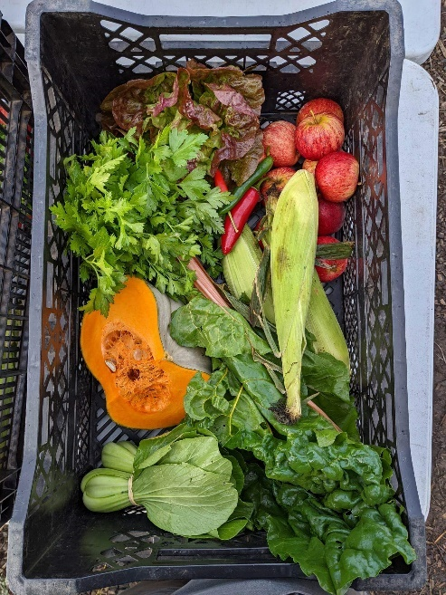
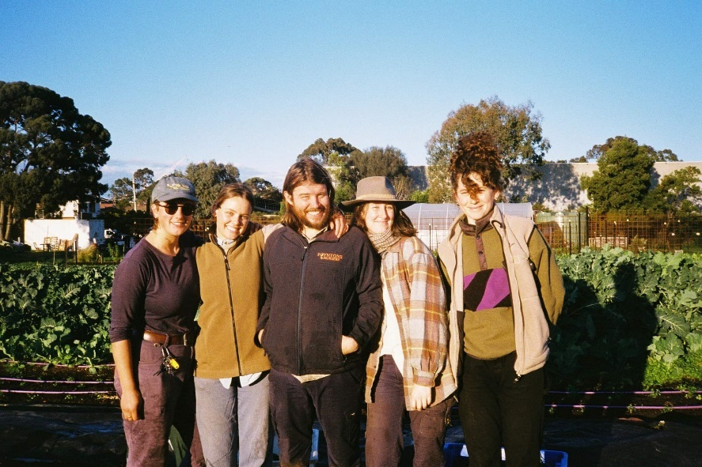
Photo credit: Farm Raiser

A community of passionate gardeners
A further strength is that three-quarters of community survey respondents indicated they grow their own food at home. Banyule respondents to Sustain's Pandemic Gardening Survey (Donati and Rose 2020) revealed the significant benefits of edible gardening. Over three-quarters (78%) reported that edible gardening has a great or significant impact on their mental health and wellbeing (defined in the survey as making gardeners feel happier and more relaxed while also reducing stress and anxiety - see Figure 6). This suggests that edible gardens, whether on public or private land, are not only an important community food assets but potentially a powerful tool for public health.
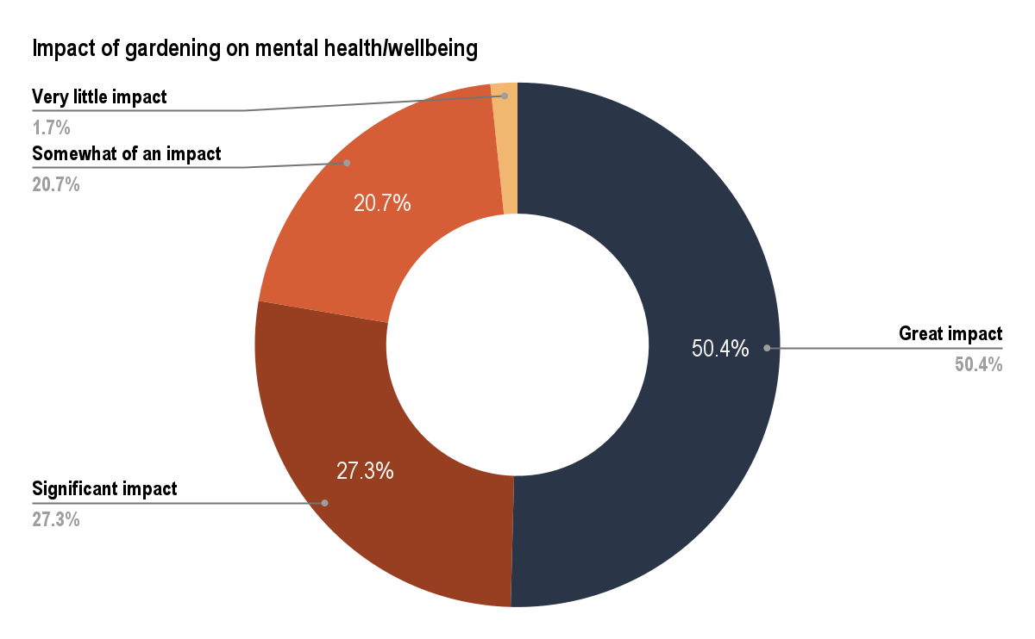
Figure 6
Edible gardening not only encourages the consumption of fresh produce, but it also fosters social connection. Three-quarters of Banyule gardeners reported sharing food with others in Sustain’s pandemic gardening survey (Donati and Rose 2020; see Figure 7).
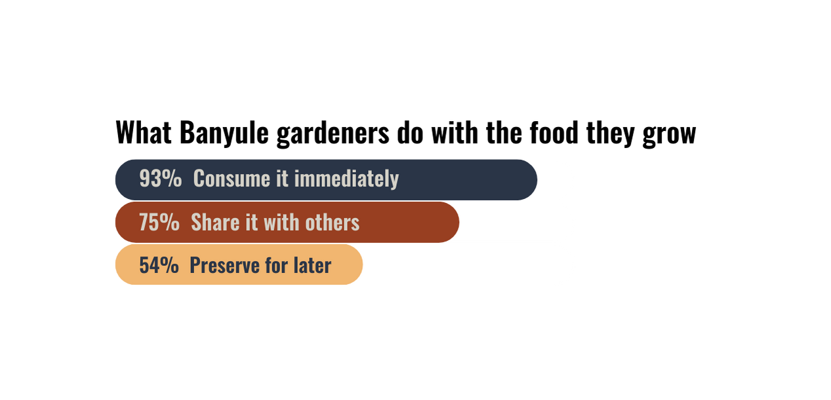
Several successful community gardens in the municipality are fostering a wealth of knowledge and expertise to share with other Banyule residents seeking information and support to grow food.
Figure 7

Abundant open spaces and bushland for growing food
Banyule has abundant bushland and open green spaces that are enjoyed by the community and contribute to the biodiversity of the local environment. Melbourne Water’s ‘Our Space, Your Place’ public map reveals a further 33 acres of land identified as ‘likely to be available for community projects and could be used for a variety of purposes depending on the space’. These spaces could be investigated in collaboration with Melbourne Water to identify further areas for growing food.

Critical issues and emerging vulnerabilities
Shared priorities between Council staff and the highly engaged Banyule community are strong foundations on which to build a healthier, more diverse, inclusive and sustainable urban food system. However, several critical and emerging vulnerabilities present significant challenges to achieving Banyule’s Community Vision 2041 and the community’s food system vision articulated during the consultation process.
Key vulnerabilities relate to the local food economy, cost of living stressors and growing food insecurity, placing new pressures on emergency food relief providers that are working hard to support vulnerable members of the community. This section explores the intersection of these vulnerabilities through an analysis of recent academic literature, socio-demographic data and themes from stakeholder and community consultation.

Cost of living pressures and deepening inequity
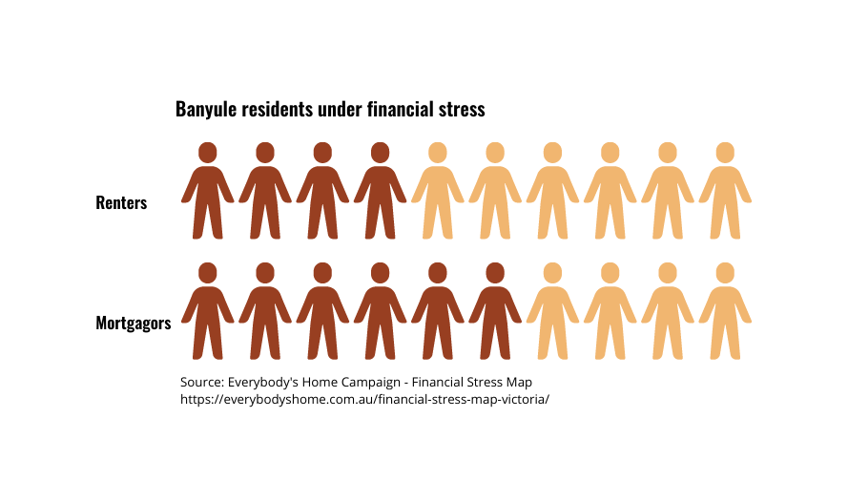
The pandemic has exacerbated economic disparity, with a significant number of renters and mortgagors under financial stress (Figure 8). The electorate of Jagajaga (covering the Banyule LGA) ranks fourteenth in the top twenty constituencies nationally for the highest level of stressed mortgagors (Thackaway and Randolph, 2021). These figures, calculated on 2021 data, do not account for eight consecutive interest rate rises since May 2022, with two further rises expected in March 2023. Households with an average mortgage of $500,000 now pay $834/month more than in April 2022.
Figure 8

Poverty and food insecurity
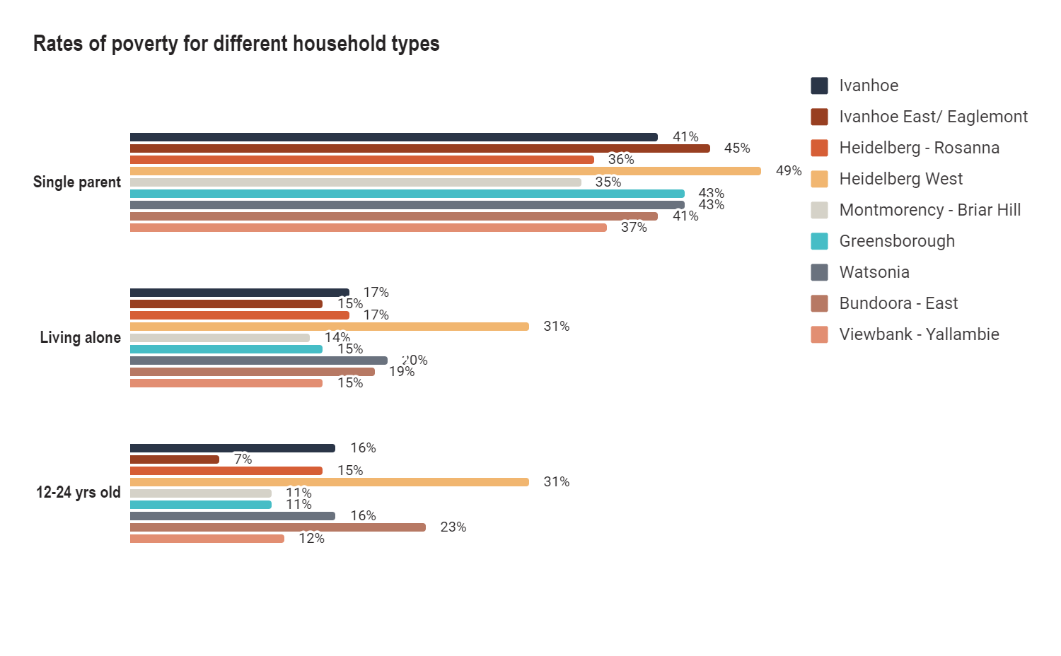
The last three years have seen sharp rises in food insecurity, resulting from loss of income during the pandemic lockdowns. Stagnant or declining household income and rising inflation is further entrenching and expanding poverty. Poverty is a leading cause of food insecurity (Bowden, 2020). The Victorian Council of Social Service Poverty Maps, created using on 2018 data, demonstrates that many Banyule residents were already vulnerable before the pandemic. Rates of poverty are highest for single parent households across all suburbs, followed by young people (under 25) and people living alone (Figure 9).
Figure 9
Source: VCOSS Poverty Maps

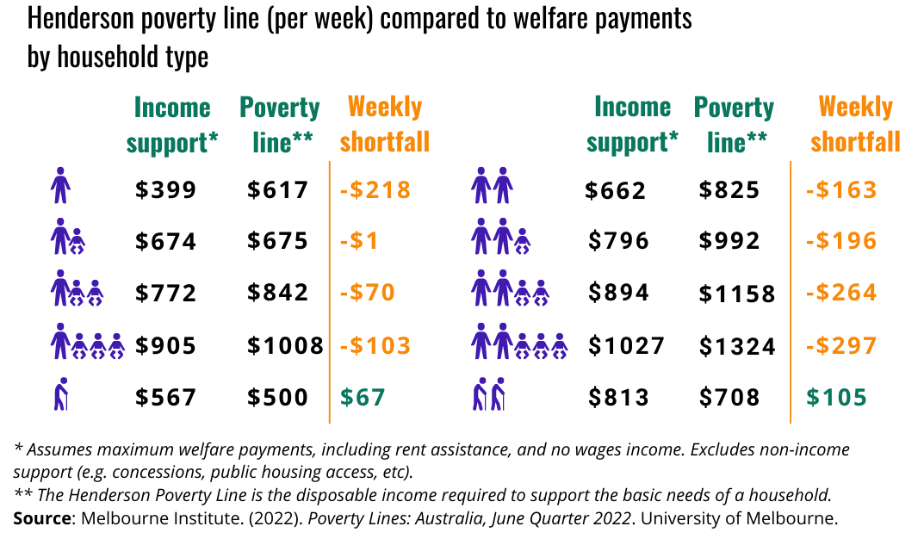
Poverty-level welfare benefits are significantly exacerbated by recent cost of living increases, forcing most household types below the Henderson poverty line (Figure 10).
Figure 10
The 2022 Foodbank Hunger Report found that increases in the cost of living and reduced or low income and government benefits were the most commonly reported drivers of food insecurity over the last twelve months, at 64% and 42% respectively. The percentage of working-age JobSeeker/Youth Allowance recipients in Banyule has remained equal to pre-pandemic levels (December 2019) (Figure 11). In Heidelberg West, Banyule’s most disadvantaged community, government benefit recipients dropped below pre-pandemic figures in November 2022 but increased sharply in January 2023, for a total percentage increase of 16% since December 2019. However the highest percentage increases of JobSeeker/Youth Allowance recipients within the municipality have been in Ivanhoe (38%), Bundoora East (36%) and Ivanhoe East/Eaglemont (25%) with the Ivanhoe and Eaglemont areas being Banyule’s least disadvantaged suburbs. This suggests that new pockets of economic vulnerability may be emerging in suburbs typically regarded as less vulnerable (though, as noted before, some household types are highly vulnerable regardless of geography). This is consistent with the 2022 Foodbank Hunger Report which identified that a much broader range of household types and income levels are now experiencing food insecurity.
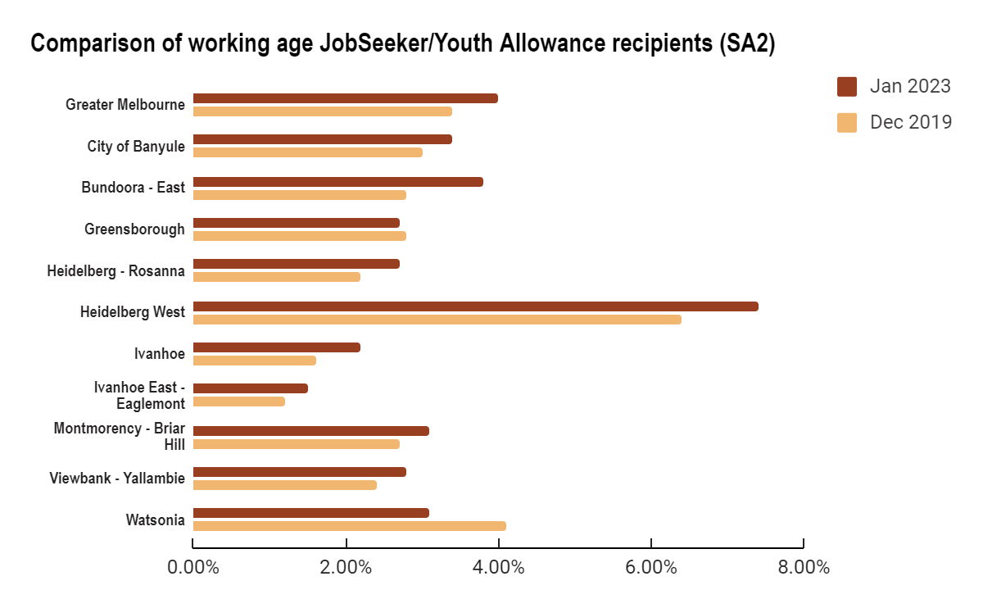

Figure 11
Source: Department of Social Services - JobSeeker and Youth Allowance recipients
% change from Dec 2019
18%↑
13%↑
36%↑
-4%↓
23%↑
16%↑
38%↑
25%↑
17%↑
-24%↓
15%↑

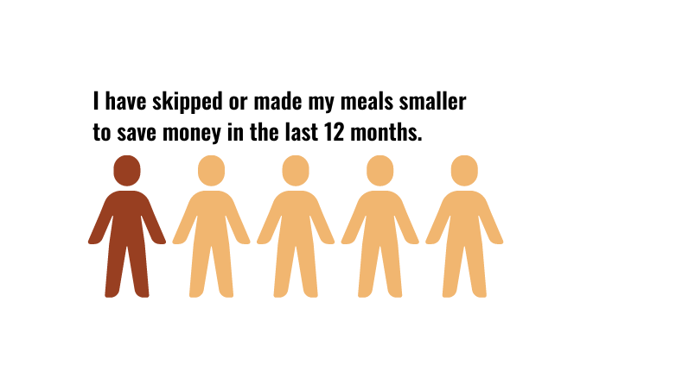
Growing food insecurity in Banyule
Figure 12
Source: Shaping Banyule Urban Food Strategy community survey
These complex economic and policy dynamics at a national level have a direct impact on the wellbeing of Banyule residents. A concerning one in five community survey respondents reported some level of food insecurity in the last year (Figure 12).
The geographical distribution of food-insecure survey respondents is consistent with other evidence that financial stress and economic precarity are growing and diversifying across the municipality. Over half (55%) of survey respondents in the North West precinct (Bundoora, Watsonia and Watsonia North) reported experiencing food insecurity compared to 13% in the West precinct (Heidelberg West/Heights and Bellfield) (Figure 13). It cannot be assumed these figures reflect actual rates of food insecurity due to smaller sample sizes at the precinct level. Rather they serve to illustrate that food insecurity is not limited to those suburbs experiencing entrenched disadvantage.
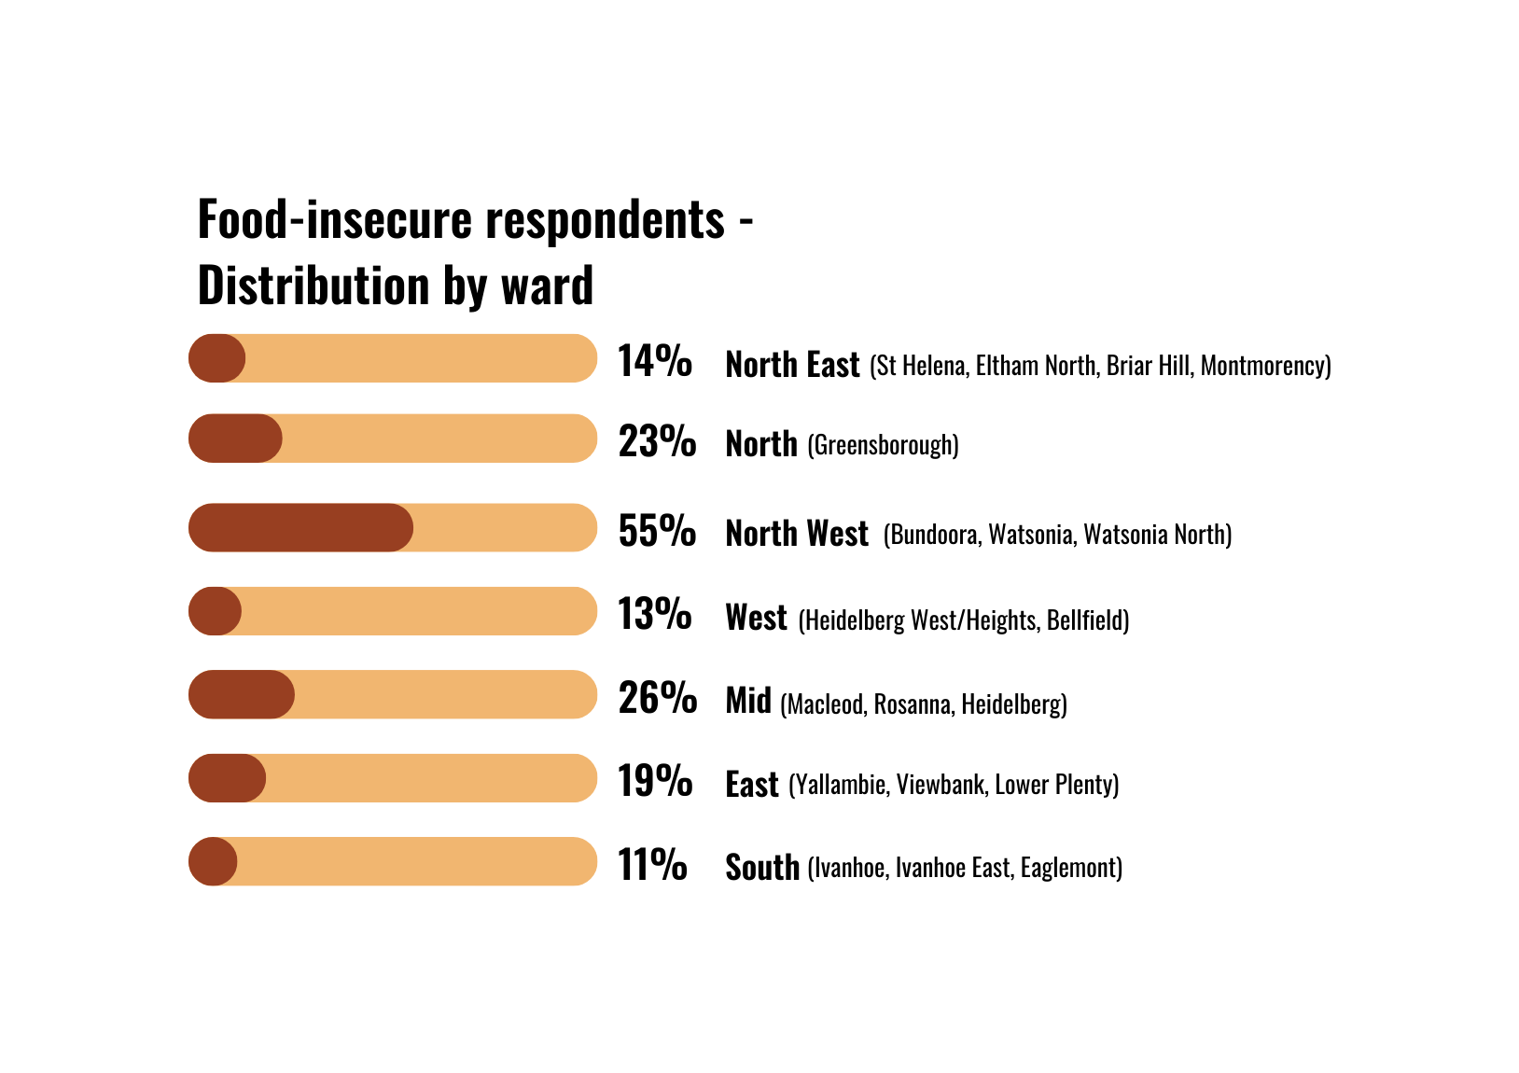
Local emergency food relief providers report that demand for food relief continues to grow. For example, BANSIC (Heidelberg West) reported a 215% increase in client demand for emergency and food relief services over a three-year period since December 2019. The agency also notes a significant increase in the last six months in clients requesting housing assistance and related difficulties. Diamond Valley Community Support in Greensborough recently reported a 22% increase in demand for emergency relief in the last year.
Figure 13
Source: Shaping Banyule Urban Food Strategy community survey
Food-insecure respondents (distribution by precinct)
Community consultation suggests there is a lack of coordination in delivering services to people who need it most, and many people may not know where to access information about food relief services. It is also possible that some food-insecure residents in disadvantaged suburbs areas may be falling through the cracks if food relief services are not operating in their local community.
Food insecurity is tied to many factors beyond Council’s control. However, the urgency of the issue highlights the need for strong food system leadership at a local level, including robust advocacy to state and federal government on issues impacting on Banyule’s vision to be an inclusive, connected and healthy community. Further research is also required to better understand, monitor and respond to food insecurity within the municipality.
Community voice
“We can't keep up with the food demand.” – Watsonia emergency food relief provider (kitchen table talk)

Vulnerabilities in the community food sector
Volunteering can foster an improved sense of wellbeing and facilitate the exchange of skills and knowledge, strengthening community capacity and building social capital at a local level. Volunteers also strengthen councils’ ability to meet commitments in their municipal health and wellbeing plans and enhance government service delivery by supporting educational activities in schools and coordinating community gardens on council land.

Community gardening and other community food initiatives
However, volunteers are not a substitute for appropriate resourcing. In community and school gardens, volunteer availability is particularly constrained over summer holidays when conditions are also hot and dry. Banyule’s community gardeners are hardworking and are willing to put in their time without financial reward. For some gardens, communities have come to rely on the goodwill of a few lead garden organisers. If they leave the area or succumb to burnout, community gardens can lose momentum and become inactive. Over-reliance on unpaid labour, and consequential volunteer burnout, was identified as the most significant constraint for 70% of urban agriculture participants in the community sector in a recent Victorian survey (Donati & Rose, 2022). Supporting community gardens and addressing volunteer burnout will become particularly important in responding to community desire for more workshops and other educational opportunities about urban food growing from their community gardens.
Community voice
"One of the things that's difficult with community doing stuff is the factor of [volunteer] burnout. When you apply for council grants, you can't put money in to pay someone, and I think there really needs to be an element of a paid coordinator for some of these projects, especially if you want to have longevity with them…"  – Montmorency resident (kitchen table talk) | "Council, 'til now, has depended on volunteers to run these programs, so they give us little bits of money. We run a program, and then it's up to us to keep it going. Volunteers burn out. Volunteers need resources. If Council is really serious about it, they need to have a dedicated program officer to run these programs or to support the community." – Montmorency resident (kitchen table talk)
“I see community gardens as a wonderful opportunity for so much. However they work well when the leaders have skills and resources. In disadvantaged areas, expecting volunteers to manage and lead is a big ask as often vulnerable people have complexities that need to be considered. I believe properly paid management is appropriate in these cases.”
– Heidelberg West resident (pandemic gardening survey)

Emergency food relief
Many emergency food relief providers, which serve the most vulnerable members of the community, are stretched to capacity and themselves vulnerable without adequate resourcing. Volunteers who distribute food parcels at Barrbunin Beek noted a decline in food donations recently, especially bread, fruit and vegetables. Another community health agency providing food relief explained there is much more work they could be doing in the community but do not have the staff to respond.
Most community food relief organisations depend heavily on volunteers, creating additional vulnerability for the sector. A strong volunteer workforce requires effective recruitment, management, training and coordination. This is particularly challenging with insufficient resources. Over time, volunteers can become overwhelmed by the work, particularly in a sector in which they regularly face distressing of inequity and hardship in their community. However, many grants offered by state and local government exclude wages from funding eligibility. This reduces capacity for effective coordination while intensifying over-reliance on volunteers.
Community voice
“A struggle that we and other agencies have is the number of volunteers we have; that’s probably our biggest need when it comes to making it work.” – Emergency food relief provider (focus group participant)
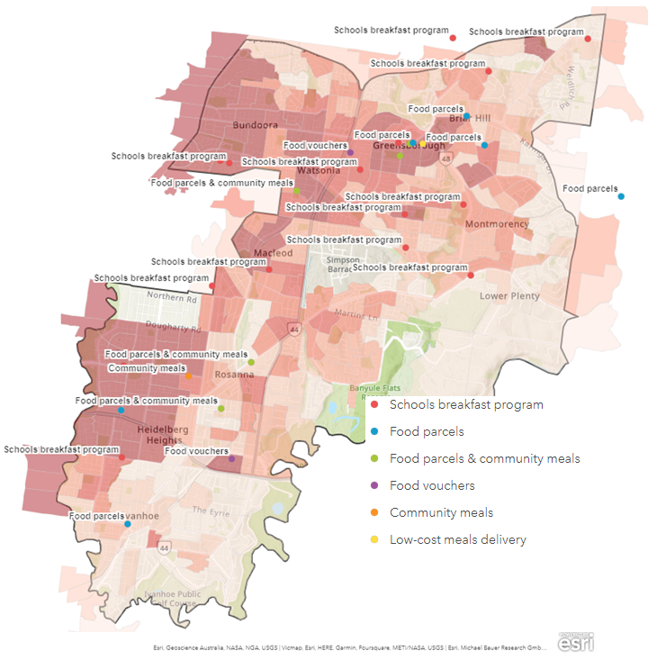
The distribution of food relief providers and services can be found at Map 2. Fifteen schools, predominantly in the northern end of the municipality, participate in the Victorian government’s School Breakfast Clubs program. While these programs meet a critical need in offering free and healthy food for students, they are also signal disadvantage.
Note: this map is indicative only as the food relief services are subject to change due to fluctuations in community demand as well as funding and other resources.
Index of Relative Socio-economic Disadvantage
Highest decile (Victoria)

Lowest decile (Victoria)
Map 2 - Distribution of food relief providers and services

A contracting food economy
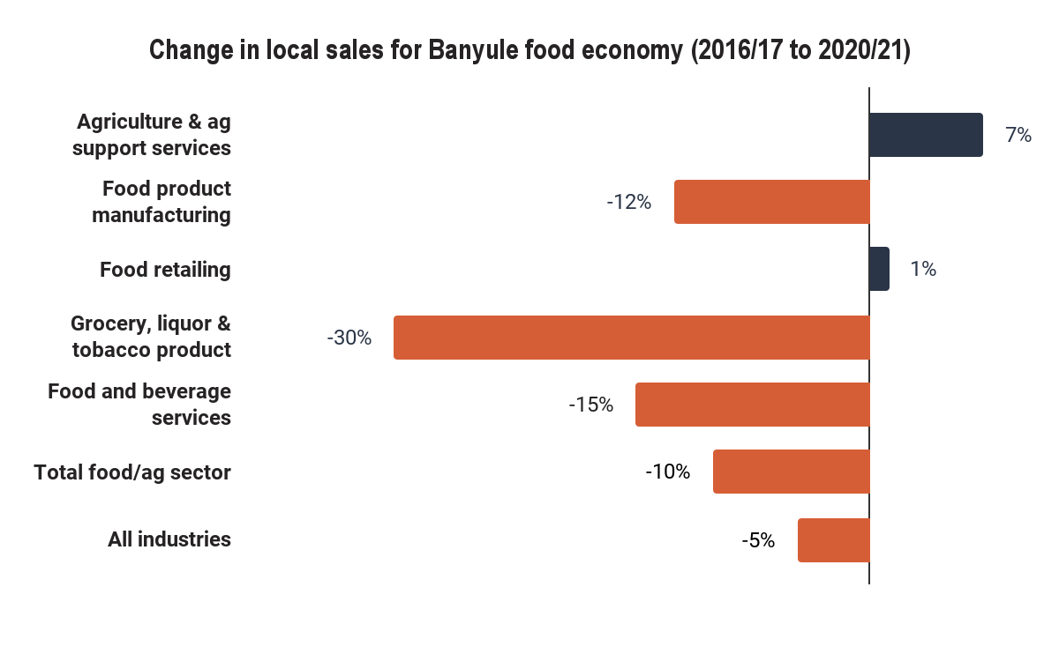
A key challenge in responding to these community priorities is that many sectors of Banyule’s food economy appear to be contracting. Local sales and employment for 2020/21 across the Banyule food economy shows a contraction since the 2016/17 financial year (Figure 14). While local sales in the agricultural sector have increased 7% and food retailing increased 1%, there has been a decline of 10% across all sub-sectors of the food industry, compared to 5% across all industry sectors.
Figure 14
Source: https://economy.id.com.au/banyule/local-sales-by-industry

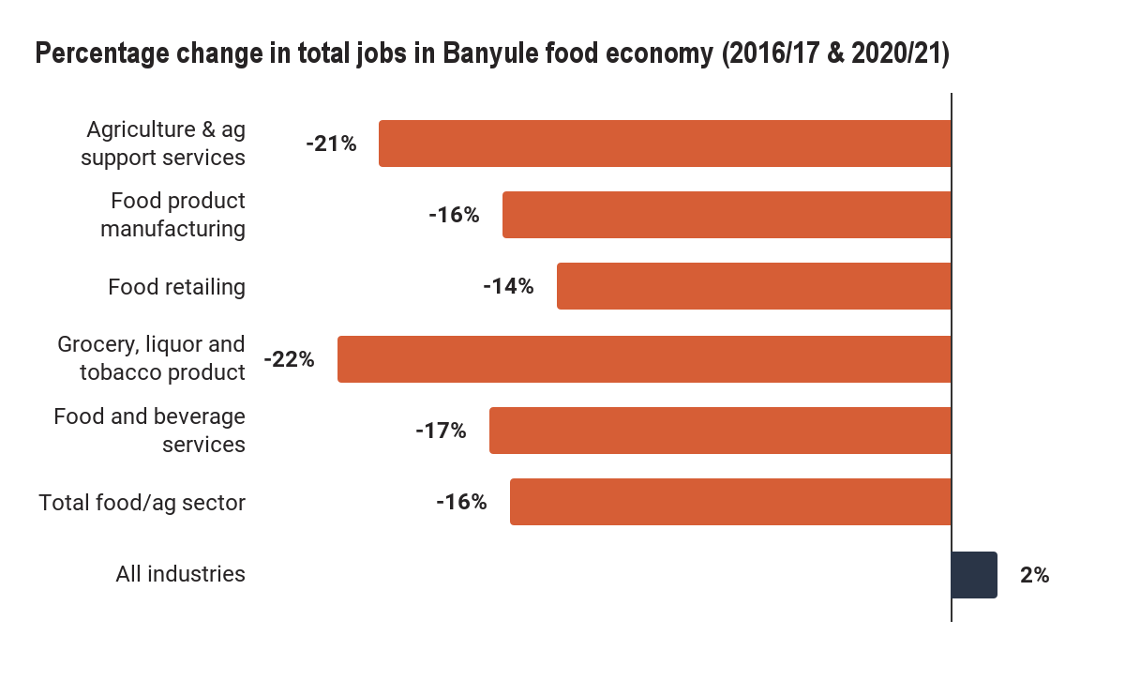
Similarly, the percentage change for total job figures (Figure 15) over the same period is a 16% decrease across the food sector, compared to a 2% increase across all industries. Jobs in food retailing fell by 14% from 2017 (ABS 2021). The percentage change of FTE employment across the food economy shows a 24% decline since 2016/17 compared to a 1% decline across all industries. It is likely the pandemic has had a significant impact on the food economy. A focused effort to support the food economy will be needed to protect local jobs and businesses. Further research is required to better understand the drivers of change within the local food economy.
Figure 15
Source: https://economy.id.com.au/banyule/employment-by-industry

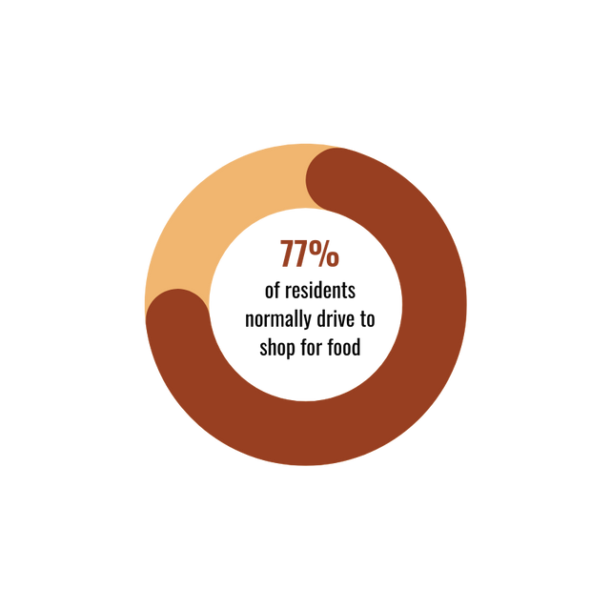
Food retailing: limited proximity and economic diversity
Figure 16
Source: Shaping Banyule Urban Food Strategy community survey
The local food environment should be considered part of what gives a neighbourhood its distinctive quality. The dominance of major supermarkets and other franchised food outlets contributes to economic homogeneity and diminishes neighbourhood character and its sense of community. Residents raised concerns about the impact of major supermarkets on local food businesses, with many closing down in some areas of Banyule.

Many Banyule residents regularly leave the municipality to access fresher, healthier, higher quality and/or cheaper food. More than half (57%) of community survey respondents report travelling outside of Banyule to do their food shopping. The reduction in food retail outlets in Banyule limits options to purchase food within walking distance. Over three-quarters (77%) drive to purchase food, while only 8% walk and 6% ride a bike (Figure 16).
Limited diversity and proximity of food businesses at a neighbourhood level can have negative economic and environmental impacts. The Department of Planning and Transport notes in its plan for 20-minute neighbourhoods, that if walking replaced half of short private vehicle trips, “it would save the Victorian economy approximately $165 million a year in congestion, health, infrastructure and environmental costs” (DELWP, 2019).
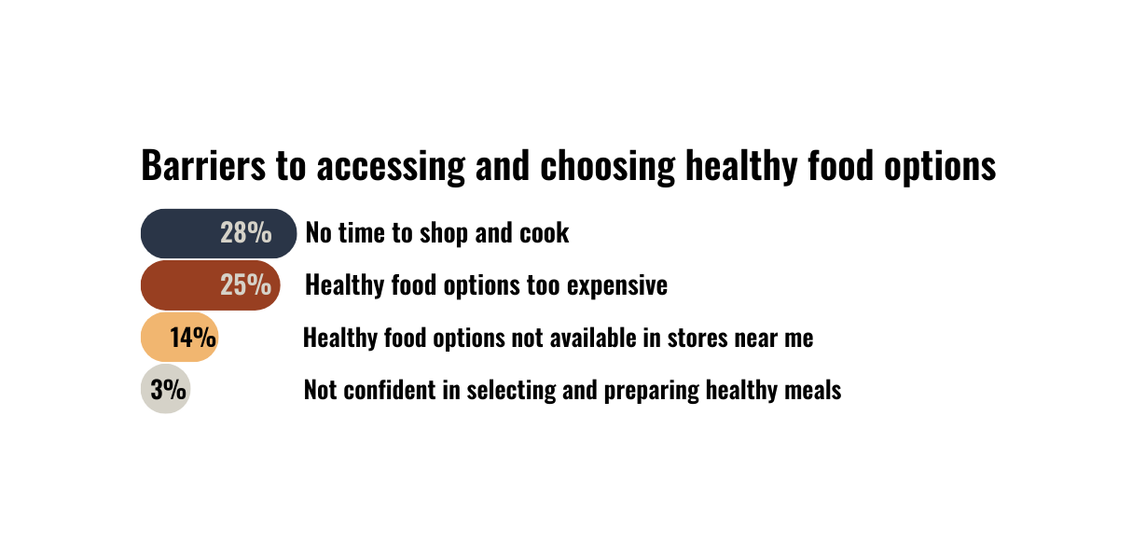
The reduction in food retail outlets in some areas or lack of local food shops in others contributes to what survey respondents cited as their main barrier to healthy eating: time. Cost, access and affordability were also major barriers to healthy eating (Figure 17). Knowledge in selecting and preparing healthy meals was not a significant barrier.
Figure 17
Source: Shaping Banyule Urban Food Strategy community survey

Community voice
“The presence of [major supermarket], namely its imposition on Turnham Avenue, is further evidence of the decline in our local area... A resilient food system cannot happen the longer we continue to allow larger supermarkets to dominate the local area. They are effectively 'greenwashing' Banyule through their ever-present advertising and sponsorship of local associations and events.”  – Heidelberg resident (community survey) | “I am disappointed that a lot of small food businesses have closed recently, e.g. the Ivanhoe Cake Shop, Brumbies Bakery in East Ivanhoe and the Eaglemont Butcher. It would be great to see Banyule promoting and supporting local independent food businesses that have to compete against the big supermarket chains.”  – Ivanhoe resident (community survey)
“Accessibility is a big one. The local farmers market to me (Eltham) runs once per week, which is great, but I don't always have time to get there. When shopping at the local green grocers it is hard to know where the food was sourced from. It would be great if there was a local shop, like the old co-ops, where people who sell at the farmers markets could also sell in the shop to make it more accessible at different times. I would like to see more local CSAs or vegie boxes available. I would purchase from those in a heartbeat."
– Greensborough resident (community survey)
“Purchasing food should be less onerous for people in my age group (over 70's) (...) We have to travel too far to shop - and would like to rely less on driving and less on supermarkets.”
– former Banyule resident (community survey)

Residents desire both walkable neighbourhoods and farmers markets. However there are currently no local markets within walking distance of town centres (with the exception of Eltham Farmers Market in Nillumbik Shire Council). More pop-up markets for buying food locally and accessing more local food was one of three top priorities for Banyule residents.
Some members of the Barrbunin Beek community had been frequent shoppers at Community Grocer in Heidelberg West and were disappointed that it had closed. Like many members of the Banyule community, Barrbunin Beek clients expressed a preference for community markets, local butchers and smaller grocery stores as these were seen to offer better quality as well as fostering stronger relationships at a neighbourhood level.

Community voice: “What would encourage or help you to buy more local food?”
“Having a quality shop near where I live would help. The only one I used to use has closed down, and the shopping centre where I do my shopping does not have a store selling fresh and locally grown vegetables.”  – Ivanhoe resident (community survey) | “Healthy food sold in nearby shops (less sweet things and snack foods). More fruit shops (several fruit shops have recently closed down or converted to delis). Currently no shops in Montmorency specialising in fruit and vegetables.”  – Montmorency resident (community survey)
“Better local greengrocer. More Asian and Middle Eastern options for fruit and veg. More varied fresh fish outlets.”  – Montmorency resident (community survey) | “Market or street stalls within easy walking distance… Local corner market umbrella stalls. Not one that requires jumping in the car.”  – Yallambie resident (community survey)

Major supermarkets as “anchor” retailers in neighbourhood planning
Major supermarket retailers are assumed to be an appropriate “anchor” retailer in precinct planning and assumed to provide good access to healthy food by policy makers. However they can present challenges for health, sustainability and cultural diversity.
Most unhealthy food in Australia is purchased from supermarkets. A recent analysis of 18,206 food products sold in major supermarkets found 36% were packaged or processed; only 12% were fruits, vegetables, nuts and legumes; and snack foods accounted for 5% of all products (FoodSwitch: State of the Food Supply Australia, 2021). The FoodSwitch report also found that over half (52%) of food products from top selling brands sold in supermarkets were classified as unhealthy (or discretionary), and 72% were ultra-processed.
Ultra-processed/packaged foods are significant contributors to landfill. Over 80% of food packaging can’t be recycled through curbside collection (WWF 2021). This food packaging is a likely contributor to the 30% of ‘other’ materials identified in Council’s 2015 bin audit (Towards Zero Waste Management Plan 2019-2023). While Council cannot ban non-recyclable food packaging, it can employ economic development strategies to support and promote small food businesses that contribute to a lower waste food economy, including greengrocers, farmers markets and bulk food shops. A secondary benefit is that these can be a healthier and more affordable option.
The highly centralised nature of supermarket supply chains mean they are less likely to offer good access to local food. Only 14% of fruits, vegetables, nuts and legumes found in major supermarkets (Coles, Woolworth, IGA & Aldi) are grown in Australia (FoodSwitch: State of the Food Supply Australia, 2021). The most affordable food options in major supermarkets are often “home brand,” but these are poor sources of local food (Coles brand - 10%, Woolworths - 9% and ALDI 4%). Many survey respondents and kitchen talk participants commented on the difficulty finding organic and/or local food in Banyule.

Lack of food diversity
Affordable culturally appropriate food is not readily available in Banyule, with only six cultural grocers identified across the municipality. The food retail environment therefore does not reflect the cultural diversity of residents, with a quarter born overseas and 20% of households speaking a language other than English at home.
A consistent message was that, while supermarkets are convenient, the quality of the fresh produce is variable and there is less diversity of produce. Many expressed frustration with the lack of diversity of fresh food available from mainstream supermarkets. Many community members from CALD backgrounds indicated they regularly travel as far as Richmond, Preston and Lalor to source their preferred cultural food products. The lack of culturally appropriate food has implications for food security as well as opportunities to express cultural identity and therefore the physical and mental wellbeing of CALD communities (Kavian et al., 2020). Access to fresh food markets, cultural grocery stores and home gardens are important sources of culturally appropriate food (Gichunge et al. 2016). Edible gardening is also an opportunity to improve cultural and dietary diversity at a local level (Donati and Rose, 2020).
Better access to farmers markets in Banyule was a high priority for many Banyule residents. While not always convenient for some, farmers markets support farmers growing a greater diversity of animal breeds and edible plant varieties which is important for preserving agro-biocultural diversity.

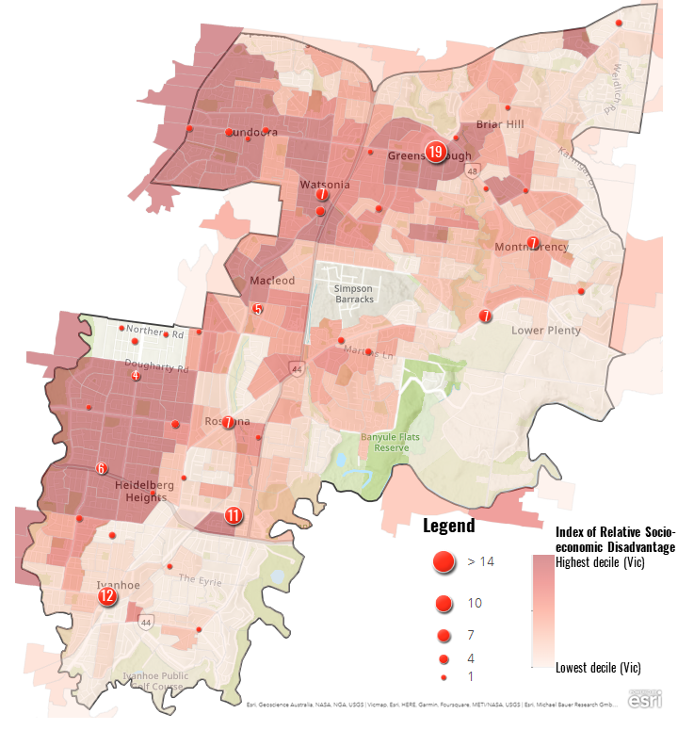
Unhealthy food environments
Map 3 – Unhealthy food clusters and disadvantage
Some suburbs within Banyule have significant clusters of unhealthy food environments.
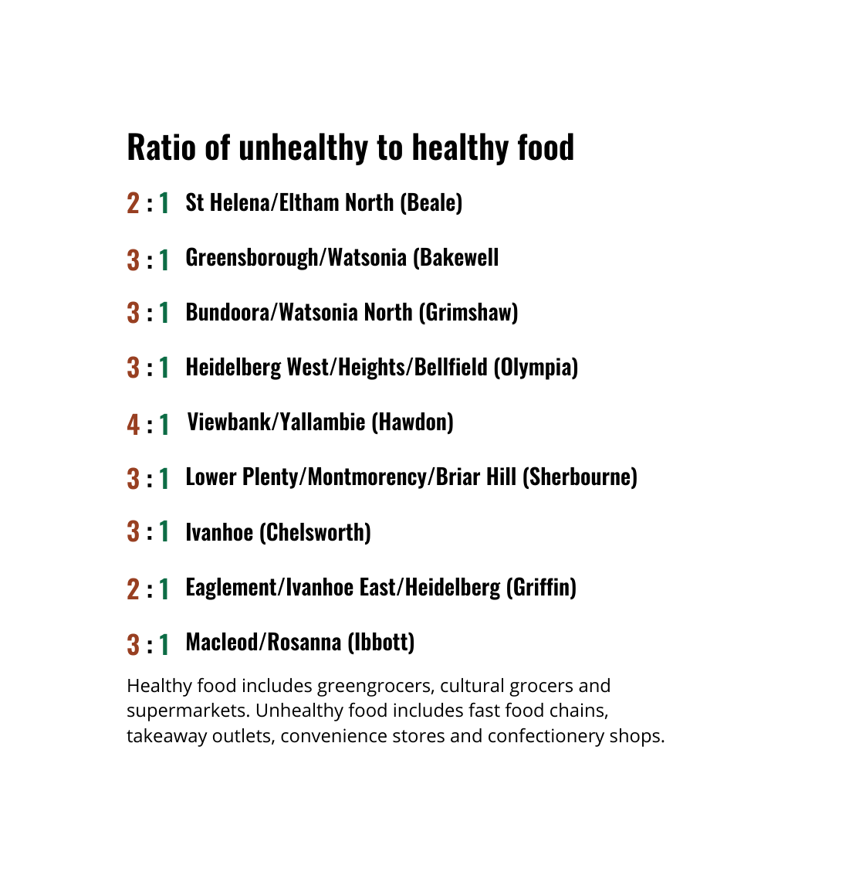
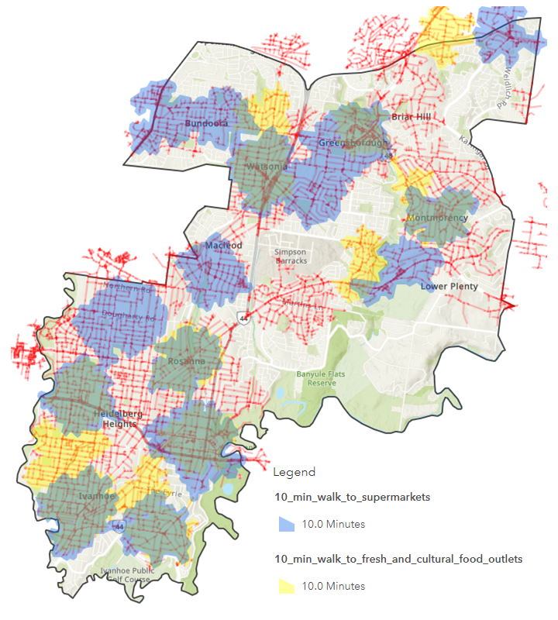
Suburbs with the highest disadvantage or in growth areas often the lowest access to fresh food and a greater proportion of unhealthy outlets (Needham et al., 2022). Map 3 layers clusters of unhealthy food outlets over Socio-Economic Indexes for Areas (SEIFA) at SA1 level, showing higher numbers of unhealthy food outlets in those localities with the highest disadvantage. The exception is Ivanhoe which also has significant numbers of unhealthy food outlets, though these are balanced by better access to healthy food. Although the ratio of healthy to unhealthy food outlets in Banyule is better than in Melbourne’s outer growth corridors, unhealthy food outlets still outnumber healthy food outlets across Banyule (Figure 18). Unhealthy food outlets are not only more numerous than healthy food outlets, but more easily accessible on foot.
Note: this map is indicative only.
Figure 18
Map 4 – Walkable access (10 mins) to unhealthy food compared to healthy food outlets

Map 4 shows walkability to unhealthy food outlets (indicated by red lines) compared to supermarkets (blue) and fresh or cultural food outlets (yellow). Green areas show the overlap of walkability to supermarkets and fresh or cultural food outlets overlap.
Note that, while supermarkets are classified as a “healthy food outlet” in the academic literature and by policy makers, they are also a significant source of unhealthy food purchases (FoodSwitch, 2021).
Note: this map is indicative only.

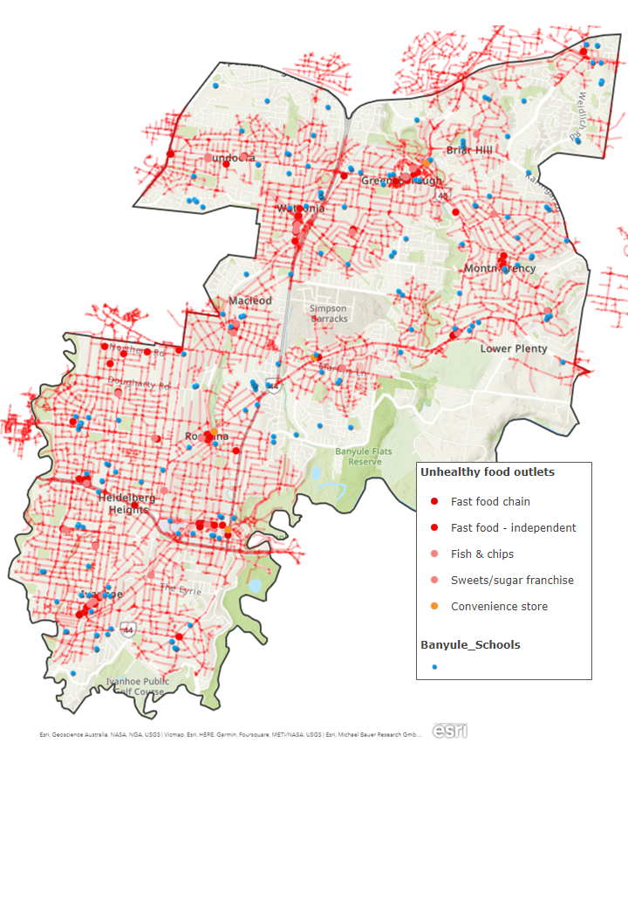
Of particular concern is the proximity of schools to unhealthy food outlets across Banyule, with almost every educational institution (childcare, primary and secondary) within 10-minute walking distance of unhealthy food (Map 5). Food environments normalise the foods and food practices children and young people are exposed to everyday. Easy access to unhealthy food also makes it more difficult to make healthier food choices. When St Pius X primary school students were asked about what they wanted to change in their food landscape, most replied wanting more healthy food and less “junk food”.
Note: this map is indicative only.
Map 5 – Proximity of schools to
unhealthy food outlets (10 min walk)
Youth voice
“Make the food more healthy, less fast food. I see too much unhealthy food.”
– Year 4/5 student (pop-up consultation)

Departmental silos
Food systems cut across multiple areas of local government work and community activity: economy, environment, climate change, health and wellbeing, open space, social enterprise and neighbourhood character, amongst others. To engage effectively with food systems planning and change requires a whole-of-system, whole-of-organisation and whole-of-community approach.
However, almost 40% of staff survey respondents indicated that they have little or no capacity or opportunity to work with other Council teams on food system issues. The nature of organisational structures, with staff working in specialised teams, can hinder the integrated and holistic approach that food system engagement requires. This point was raised in a staff focus group, with participants noting that there was a risk of the Urban Food Strategy becoming siloed within team.
The best approach to address this issue is through the formation of a cross-Council food systems working group to support ongoing engagement and capacity building and to ensure that food system priorities are considered in the review of related Council strategies and plans (e.g. the Urban Forest Strategy, Neighbourhood Character Strategy, etc).

8. Opportunities, community priorities and recommendations

Theme 1 - An inclusive and connected food community
Food is a basic human necessity but also a tool for connection, celebration and inclusion of diverse cultural identities. Many Banyule residents value food as central to their social lives and connection to community. They wish to see food recognised and valued for its unique role in community building.
Community voice
“A strategy about food [is] about climate change, wellbeing, connecting those people who are lonely in our community with each-other, and giving them a sense of purpose, giving them a sense of meaning…”  – Montmorency resident (kitchen table talk) | “We need to slow down and create the environment that supports people – yes, physically and nutritionally, but also psychologically back to being in our community. "  – Montmorency resident (kitchen table talk)

A food secure community
Residents are concerned with the current level of food insecurity in Banyule and expect that effective action will be taken to address this. Community workshop participants were concerned that community gardens and emergency food relief could be mistakenly seen as guaranteeing food security for vulnerable residents. It was emphasised that it is critical that the strategy reflect a multifaceted approach to addressing food insecurity that addresses financial security as well as physical access to nutritious food.
Council officers and executives were aware of the need for emergency food relief in their community and supported the Strategy’s role in addressing this.
Community voice
“We try to provide food in a way that you don’t need to tell us your story. We don’t know need to know why.”
– Watsonia emergency food relief provider (kitchen table talk)

Valuing diversity and inclusion
Residents seek opportunities to connect and celebrate their diverse cultures in ways that value traditional knowledge and intergenerational skill sharing. Community gardens are an important source of culturally appropriate food that is not accessible in retail outlets, but often struggle to reach and attract the culturally diverse groups that could most benefit from them. Neighbourhood houses are seen as important centres for these activities, providing young and elderly residents with opportunities for meaningful connection.
Community voice
“We've lost our older people guiding our younger people. (…) There is a role for older people to be with younger people and food is a key part of that.” – Montmorency resident (kitchen table talk)

Sharing information about local food
Local Food Connect is a valuable resource for local food and community food initiatives. However, not all residents are aware of this resource, and it relies almost entirely on volunteers. Kitchen table talk participants felt greater support for Local Food Connect could provide Banyule residents with better access to information about nearby farmers markets, urban farms, food swaps and community food relief. This could include using Council’s communication channels to promote this information to a broader audience.

Recommendations for the Urban Food Strategy
- Create more opportunities for connection and networking, e.g. through food events, markets, festivals and related activities.
- Explore options to support a local food relief network to connect and network agencies and groups
- Explore opportunities to resource existing local food networks like Local Food Connect and the Teachers Environment Network (TEN)
- Explore opportunities to connect growers with focus on supporting the elderly
- Upskill smaller community gardens and food relief organisations in attracting and managing volunteers
- Consider actions which address immediate need (via support for emergency food relief) as well broader systemic issues that require advocacy to state and federal government

Theme 2 - A thriving local food economy
Strong community demand to purchase local food and shop locally is a clear opportunity. Residents’ top priority for the Banyule community was more opportunities to buy local food within Banyule (community survey). Community food initiatives including food swaps and pop-up markets (50%) and opportunities to grow food and sustainable agriculture in and around Banyule (with food production in the form of sustainable agriculture and urban agriculture (ranked equally at 36%) were also high priorities. Encouraging the development of local food systems, such as farmers' markets and other community food initiatives, could meet the demand for local food while also supporting a thriving local food economy.
Consultation with stakeholders revealed a strong desire for a more strategic and integrated approach to activity centres with a focus on place-making and catering to the needs of the local community. The transition to a circular economy was identified as creating many opportunities for training, engagement and networking.

Leveraging opportunities from the La Trobe NEIC / University City of the Future
The Strategy could consider opportunities to support industry sub-sectors such as food retailing and food/beverages services by leveraging stronger connections to other growth sectors including the La Trobe NEIC, the University City of the Future and master planning processes for the Heidelberg West Business Park. Alignment with the Social Enterprise Action Plan and the Inclusive Local Jobs Strategy represent clear synergies. A diversity of food retailing offering access to fresh produce and other day-to-day food items could encourage employees within these economic clusters to shop locally.
Community voice
“As an organisation, the City of Banyule is right to do this. There are big opportunities in Open Space, and with the new Economy Development Strategy [and the La Trobe NEIC], the timing is perfect.”
– Council manager (focus group)

Support local food enterprises with marketing campaigns
There is a clear opportunity for a ‘buy local, shop local’ marketing campaign, aligned with economic development priorities to foster new food businesses and social enterprises (Inclusive Local Jobs Strategy). Local food businesses could benefit from professional employees working within Banyule seeking to eat out or purchase groceries on their way home from work.

Community voice
“I participate in the veg boxes by Farm Raiser, and the fact that they deliver is central to my ability to access/participate. I don't have a car, so always find it hard to get to local farms and/or pick up veg boxes on a regular basis [...] So the fact that they deliver and select all the veg is important. I also like that it's transparently local. It's clear where things are coming from. It's also comparably priced to supermarkets. Finally, I like that it's run by young people." – Bellfield resident (community survey)

Celebrate the local food sector through community events
Best practice for food system strategy implementation involves collaboration, communication and visibility. Consistent with the Economic Development and Inclusive Local Jobs Strategies as well as goals to grow the visitor economy, Banyule could explore opportunities to coordinate and promote a Banyule Urban Food Festival. This can be an annual event, showcasing urban farms, food-based social enterprises, cultural food traditions and emerging food-based start-ups and more.

Recommendations for the Urban Food Strategy
- Develop and implement a local food marketing campaign
- Leverage the Social Enterprise Action Plan and Inclusive Local Jobs Strategy to explore and promote opportunities for food-based businesses, including urban farms
- Leverage opportunities and partnerships emerging through the La Trobe NEIC to foster and support new, innovative food retail and value-adding businesses
- Explore opportunities to work with local schools and vocational training providers, including the Banyule-Nillumbik Learn Local Employment Network, to promote training and employment pathways in urban agriculture and food businesses
- Investigate options to convene an annual Banyule Urban Food Festival to highlight and celebrate local produce, value-adding and hospitality businesses

Theme 3 - Planning for healthy and sustainable food environments
The food system is vital urban infrastructure, and access to healthy, affordable and sustainable food contributes to neighbourhood character and creates a sense of belonging. It should therefore be a core element of neighbourhood and precinct planning. Healthy and sustainable food environments ought not be left to chance but rather integrated into the local planning scheme through conscious design and collaborative decision-making at the neighbourhood, precinct and municipal levels. A more diverse range of local food businesses was seen as an opportunity to give local neighbourhoods a “village feel” enjoyed in Banyule’s more affluent neighbourhoods.

Enabling healthy and affordable food access at the neighbourhood level
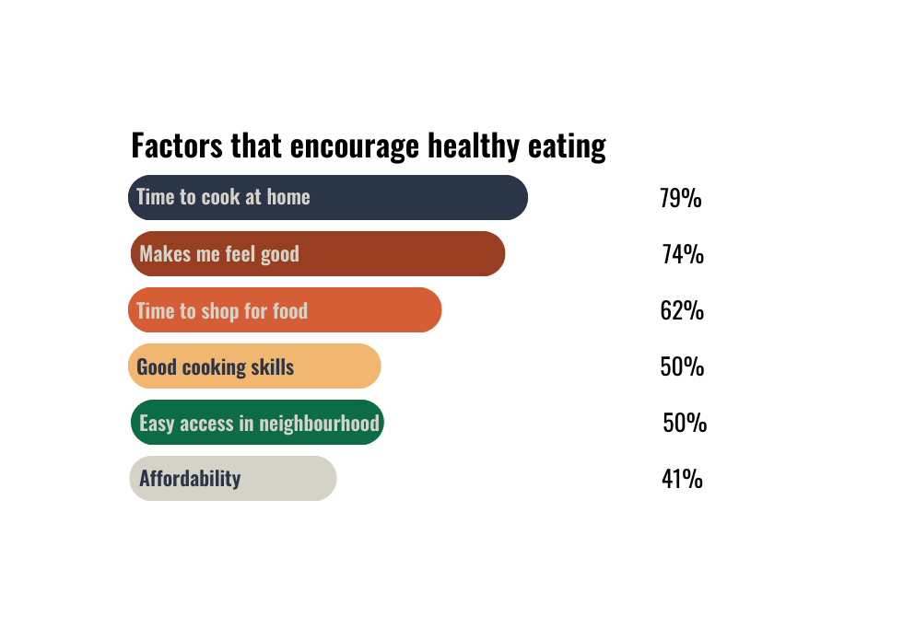
The common perception is that healthy food eating requires better knowledge and education. However, this was not consistent with the community survey/ Time to cook and shop for food featured strongly as an enabling factor for healthy eating, along with being able to access healthy food in the neighbourhood (Figure 19). This includes the hospitality sector as well as grocery and food retailing.
Figure 19
Source: Shaping Banyule Urban Food Strategy community survey

Community voice
“I would like to see more healthy and sustainable hospitality venues in Banyule. If we are not cooking at home, we are very limited in healthy eating options and often have to compromise on our healthy eating preferences.”
– Lower Plenty resident (community survey)

Fiscal and other incentives to retain and encourage healthy food outlets

As noted earlier, residents indicated dissatisfaction with currently available options for healthy, affordable and culturally appropriate food in many areas of the municipality. This especially applies to greengrocers and cultural food outlets (such as Asian and Indian grocers). In the development of this Strategy, Council could consider what incentives (fiscal and planning) are available to retain existing grocers and cultural food outlets and encourage others to open. There is strong evidence that fiscal incentives such as reduced rates to support and encourage healthy food outlets such greengrocers, farmers (or pop-up) markets and bulk food outlets could have multiple benefits, including:

- improving affordability of local food access,
- increasing consumption of fresh produce,
- reducing food packaging.

A comparison of fresh produce prices in farmers markets, supermarkets and greengrocers across Victoria found greengrocers were “significantly cheaper” that supermarkets but offered “the same availability of fresh fruit and vegetables as supermarkets and more availability than farmers’ markets” (Abley et al., 2020, p. 832). They also offer vastly fewer ultra-processed and unhealthy food options compared to supermarkets. Aggregated data from four quarterly surveys (winter 2015 to autumn 2016) undertaken by Local Food Connect compared prices for fresh produce at the Eltham Farmers Market.

Across 150 fruit and vegetable items, greengrocers were the cheaper option 53% of the time compared to 20% for supermarkets. Across 135 fruit and vegetable items, farmers markets are cheaper on average 44% of the time compared to 22% for supermarkets. The greengrocer was the cheapest option for vegetables, and the farmers market was most affordable for fruit (with some seasonal variation). This challenges the common perception that supermarkets are the most affordable option for seasonal fruit and vegetables. Bulk food outlets are another opportunity for providing affordable, low/no-waste options for healthy food options such as pulses, grains and other common pantry items.

Greengrocers and other smaller food retailers also build community and neighbourhood character through the personal relationships that these family businesses develop over time with customers. This importance of small shops in building community relationships was noted by Barrbunin Beek clients.

Community voice
“An affordable bulk store would be great, but it takes funding to get off the ground. Attempts to get buying groups started have stalled because it’s just too much work to do voluntarily, there’s no space to store foods and it takes funds to buy heaps up front.” – Heidelberg West (kitchen table talk)

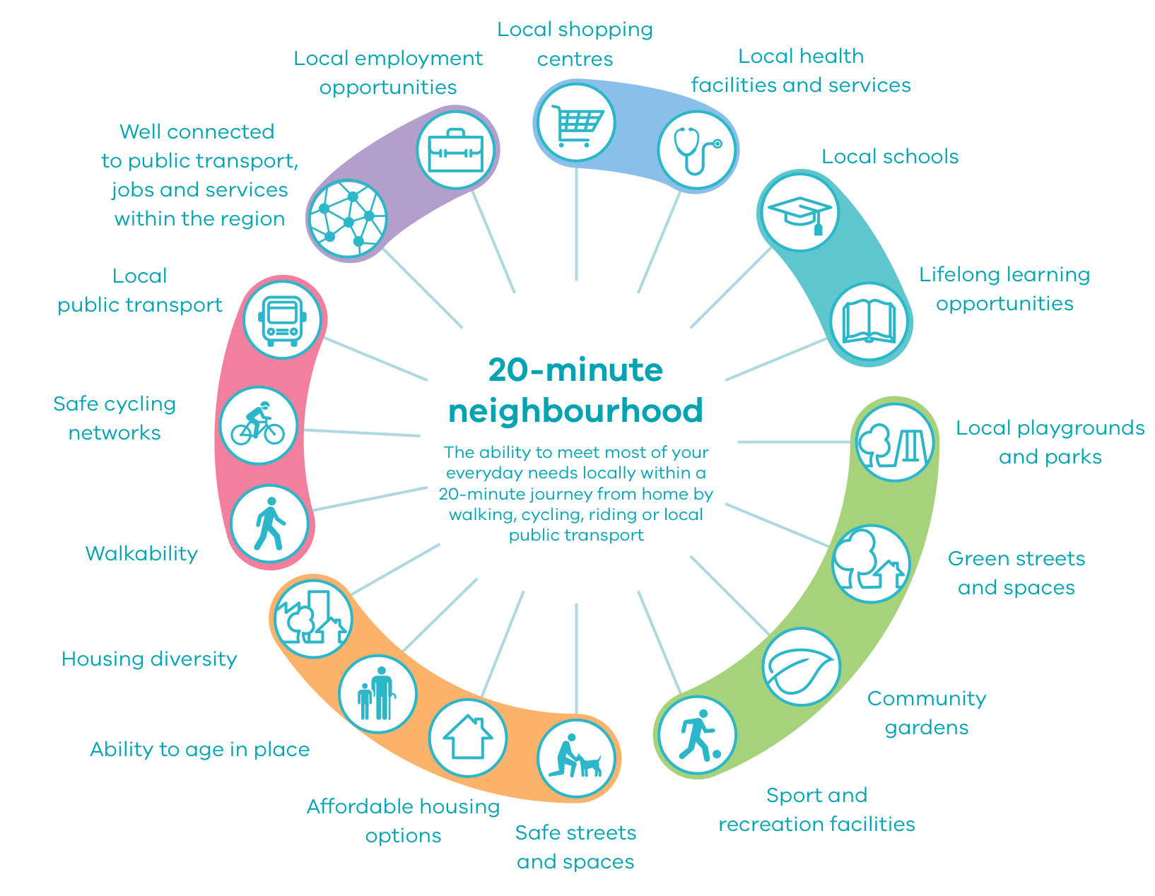
Applying a ‘food lens’ to neighbourhood and precinct planning
Twenty-minute neighbourhoods are a key sustainability target for Plan Melbourne 2017-2050 (Figure 20). This implies all Melbourne residents should be able to access their basic daily needs within 20-minutes of their home, either cycling, walking or public transport. However, the built form and urban planning inherited across the city in recent decades favours private car use. Large supermarkets require significant car parks which reduce neighbourhood character and amenity.
Figure 20
Source: Plan Melbourne 2017-2050
With ongoing work on Active Banyule, Neighbourhood Character and Liveability, there is a major opportunity for Banyule City Council to work with residents in planning for truly sustainable neighbourhoods, which would include a much greater range of options to purchase healthy, affordable and culturally appropriate food.
Community voice
“Residents need to hold councils accountable to create more fairness and to implement sustainability policy encompassing food security, environmental protection, renewable energy, safe and secure public transport, bike tracks and pedestrian walkways, public health and wellbeing programs. After all, the physical and psychosocial health of the community is at the core of thriving communities and must be in the local and national interest.”
– Heidelberg resident (pandemic gardening survey)

A zero-waste urban food system
Residents welcome FOGO and appreciate being able to keep food waste out of landfill. They expressed a strong desire to expand the scheme to apartments, businesses and in public places. Community composting systems, like those operating in the cities of Melbourne and Merri-Bek as well as Cardinia Shire offer examples of how to build on community enthusiasm for applying circular economy principles to food waste management to support nutrient cycling within the Banyule community.

Recommendations for the Urban Food Strategy
- Consider setting a target for more Banyule residents to meet more of their food needs locally - an increase of 50% within four years
- Investigate fiscal incentives to supporting and encourage existing and new greengrocers and other healthy food retailers (including bulk food stores)
- Align the Urban Food Strategy objectives with the work on Active Banyule, Neighbourhood Character and Liveability to embrace the challenge of including food in design and planning for 20-minute neighbourhoods
- Apply a ‘food lens’ to precinct planning and neighbourhood character assessment
- Consider options to expand FOGO to food businesses, apartments and public spaces
- Scope options to create a community composting pilot to engage community members and build enthusiasm for circular economy principles
- Investigate opportunities to embed disability parking in planning of food environments

Theme 4 - Abundant edible landscapes
Edible gardening has significant benefits for the mental and dietary health and wellbeing of Banyule residents, and the community is seeking more opportunities, skills and spaces to grow food. A recurring theme across the consultation process concerned the desire for more spaces for edible gardening and ensuring residents in all dwelling types have equal opportunity to grow food. This may include unlocking or facilitating access to land for urban farms and community gardens, simplifying processes to start community gardens, integrating communal gardening spaces close to or within high density housing and exploring opportunities for sharing land.

Unlocking spaces for food production
While Banyule may not have large existing market garden and agricultural areas, or large tracts of Council-owned land, it does have a quantity of under-utilised parcels such as transmission easements, lightly used open space reserves and land held by entities such as schools that could be used for food growing and community gardening. Farm Raiser’s partnership with Waratah Special Development School is one excellent model of how this could be achieved. Similar discussions are underway with Rosanna Primary School. Given the many large backyards in Banyule, an expansion of home-based gardening, potentially through land-sharing arrangements like Growing Farmers, is also an opportunity.

Community voice
“Banyule is ripe for home gardens, since we have lots of single houses with big backyards.”  – Council manager (focus group) | “Public spaces… I would like to see the Council supporting nature strip gardening (edible and indigenous planting) and producing some guidelines on this."  – Heidelberg West resident (community survey)
An option for responding to this community demand through the Urban Food Strategy could involve integrating edible plants in the upcoming review of the Urban Forest Strategy and reviewing current local laws and planning requirements to identify unnecessary restrictions or prohibitions and opportunities to encourage more edible spaces. This may include creating a more permissive framework for growing food in public spaces, simplifying processes and providing assistance to start community gardens and urban farms and finding ways to integrate edible spaces into the design of new developments. Council could also facilitate access to land for community groups or aspiring urban farmers by mapping and publicly sharing suitable land opportunities and leveraging their relationships within the municipality.
Edible spaces intersect with sustainability outcomes for new builds and the local biodiversity. Encouraging the planting of edible native plants on bushland reserves can contribute to local biodiversity while also providing opportunities to integrate Indigenous foodways and culture into the local community.
Community voice
“When I walk past these little patches, like parks with one swing that no-one ever uses… I look at them and think: this could be an orchard, this could be a herb garden, this could be an interactive children's play space with food in it, that the local community supports and uses and benefits from. It just seems so obvious, that there's all this gorgeous land that isn't utilised. And it's ours -- not council’s -- we, the community, contribute to that land through our rates."  – Montmorency resident (kitchen table talk) | “Those that need [community gardens] most are often excluded. Council requirements for governance structures are extremely difficult to comply with. I've seen highly educated and motivated groups burn out from the effort of setting up a community garden. We need greater support from Council particularly with accessing land that has water and with simplifying the governance requirements and/or supporting disadvantaged groups to get involved. We need more community gardens that are communal e.g. help-yourself herb patches, community orchards rather than individual plots.”  – Ivanhoe resident (pandemic gardening survey)

Empower the community to grow food
The Urban Food Strategy can empower new and experienced gardeners to grow food for themselves and their community. Residents are seeking opportunities to learn how to grow food, both getting started and how to support established gardens. People want regular, simple and time-effective educational opportunities. Community gardens run a small number of volunteer-led workshops for the broader community. However leaders stress that they are at capacity and need support to run more workshops. Farming and community gardening leaders identify the possibility of mentoring programs in the community to help establish community gardens and urban farms, teach new and young growers and share skills, knowledge and equipment. The My Smart Garden program (currently supported by eight Melbourne councils) could be a welcome additional source of workshops for many Banyule home gardeners.

Community voice
“People will need support, education and guidance to rediscover the skill of food growing. It is not an easy thing to do.”  – Greensborough resident (pandemic gardening survey) | “I want to grow my own food now because of the cost, but also because it’s organic. I don’t trust the supermarkets.”  – Barrbunin Beek client (pop-up consultation)

Young people can engage with their food system by growing food, building connections, friendships and healthy habits. Schools are already doing some of this work educating school aged members of the community (including talking about healthy eating and food waste). Residents called for more gardening education in schools and more support for teachers and helpers to teach cooking and gardening in schools.
Over a third of community survey respondents do not currently have a garden but would like access to growing space and to learn more about growing food. Residents identified the following barriers to edible gardening in Banyule: fruit fly, the cost of starting edible gardens, the lack of accessibility of community gardens for CALD communities, concerns about soil contaminants and lack of knowledge or information to grow food or find a community garden. Many ideas were suggested to overcome these barriers, such as a fruit fly management policy, subsidies to start edible gardens at home and providing access to soil testing and other essential resources.

Expand community orchards
There was a strong desire for the Council to plant more fruit trees. Many residents echoed their positive experiences and observations of how the public looked after existing fruit and olive trees, ensuring that the produce was picked when ripe and not left on the ground to become a safety hazard or problem with pests. Residents expressed how the few examples of currently available fruit trees foster local relationships and desire to look after the local environment. There is clear alignment here with the Urban Forest Strategy, which is supported internally by many Council staff.

Support local and regional food production
Council staff and residents identify the importance of food production in Banyule and the greater Melbourne area as key to future proofing the community’s food supply, reducing emissions and creating healthier food options.
Residents would love to see more urban farms like Farmraiser and Beales Road farm that sell their produce locally and donate or subsidise their produce for local First Nations people and residents experiencing hardship. Council could help support the growth of local food production by creating long and short term targets for urban farms, creating a grant pool or seed funding for establishment costs, facilitating a mentoring program and facilitating networks or forums for knowledge and resource sharing.
Banyule City Council can play a role in advocating to the state government to protect Melbourne’s food bowl, including advocating to the state government to stop rezoning productive agricultural land around Melbourne for housing.
Community voice
“[It would be] good to see an increase in urban farming and support for local producers and opportunities to buy direct from producers online or via farmers markets.”  – Heidelberg West/Heights resident (pandemic gardening survey) | “Regarding the planning department, we need stronger policies or by-laws that support small-scale food production.”  – Food business owner (focus group)

First Nations priorities, foodways and connection to Country
Acknowledging connection to Country and First Nations custodianship of the suburbs that comprise Banyule was a high priority for many residents. Volunteers and clients at Barrbunin Beek Aboriginal Gathering Place enjoyed opportunities to share and connect over food, with many seeing food as a way of expressing care. There was unanimous agreement that more food hampers would be beneficial for the community. Cooking classes to teach adults and young people how to make easy recipes (see page 3 of this report) and recipe cards in food hampers to provide cooking inspiration for recipients were also suggested. As with the broader Banyule community, growing food was a priority for many people at Barrbunin Beek, with some already growing the own food and others wishing to do so.

Partnerships with Wurundjeri Narrap Team, Wurundjeri elders and First Nations residents could provide opportunities to embed Indigenous foodways into the Banyule environment along with educational opportunities to foster cultural learning and caring for Country across the community.

First Nations custodianship of Country should be explicit in the Urban Food Strategy, supporting Council’s Reconciliation Action Plan, the work of Reconciliation Banyule and allied initiatives taking place at the State (Treaty) and Federal (Voice to Parliament) levels.

Community voice
“Food is a way to care.”  – Barrbunin Beek client (pop-up consultation) | “[Council can help people] grow food so kids and everyone can learn how to grow food and be proud of what they grow.”  – Barrbunin Beek client (pop-up consultation)

Recommendations for the Urban Food Strategy
- Seek opportunities for communal and shared land for growing and sharing food
- Consult with Barrbunin Beek Community Committee about opportunities to integrate a community garden into the Gathering Place
- Map and share suitable land opportunities for community gardens and urban farms and help facilitate access to land
- Develop a framework for establishing community gardens and urban farms in the municipality
- Facilitate a mentoring program or community forum for community gardens and urban farmers to support new community gardens, urban farms and gardeners
- Identify opportunities for food and sustainability to be integrated into TEN workshops and forward planning sessions, including incorporating presenters for food-specific topics
- Promote and support urban agriculture activities (e.g. garden tours, food swaps and workshops) and gastronomic skill sharing (eg. preserving, passata making, etc)
- Provide educational, resources (such soil testing kits and information), networking and (as possible) financial support for food growers
- Investigate opportunities to consider food production in the upcoming review of the Biodiversity Plan, including community education on Indigenous pollinator plants, agro-biodiversity, seed saving and other related concerns
- Partner with Wurundjeri Narrap Team, Wurundjeri elders and the First Nations residents in Banyule to explore opportunities for embedding Indigenous foodways into Banyule environment
- Create a map to help identify locations of publicly accessible fruit trees, planter boxes and fresh food markets
- Consider joining the My Smart Garden program to expand garden education and skill sharing for Banyule residents
- Identify opportunities for food production (including fruit trees and other edible perennials) to be integrated with the Urban Forest Strategy implementation
- Develop a fruit fly management policy

Theme 5 - Good food system governance
Good governance is a core enabler of an effective Urban Food Strategy. Good governance enables the systems, resources and people required to support the Strategy’s implementation. This includes managing and responding to community expectations, values and needs; providing a coordination function; collaborating with the community; and ensuring policy coherence and alignment across Council strategies, policies and plans to avoid the siloed thinking that hampers effective implementation. Effective resourcing and strong leadership support are essential elements of good food system governance.
Community voice
“Council has a role to play in addressing food systems, but it requires a collaborative partnership approach with community, industry and government." – Council employee (staff survey)

Effective and collaborative coordination of food system actors
A diversity of projects, initiatives and organisations are working hard to tackle various issues with the urban food system, and some collaboration and resource sharing takes place amongst closely allied organisations working in the same sector (e.g. Veggie Empire and Farm Raiser). However, many community members and organisations reflected on the lack of visibility and coordination of diverse community food initiatives, projects and actors which hinders opportunities for coordination across shared agendas. Other residents were unfamiliar with many key features of the urban food system, such as community gardens, food relief agencies and support services, social enterprises and outlets to obtain local fresh and value-added produce.
A more coordinated approach would facilitate greater connection between environmental educators (such as the TEN), urban farmers and community gardens, emergency food relief providers and neighbourhood/community houses. The evolution of the Banyule Food Strategy Working Group into a Banyule Urban Food Coalition was identified as one way that Council could facilitate connection across Banyule and support the coordination of action at a local level.
Community food practitioners suggested that Council could play a larger role in supporting emergency food relief organisations, by providing them with community spaces to distribute food and using Council communication platforms to let residents know where to access food. This could be a consideration in the Community Infrastructure Plan.
Community voice
“Council could take a role in helping to facilitate the conversation and dialogue in the community around food insecurity.” – Emergency food relief provider (focus group)

Making the strategy visible
Promoting the Urban Food Strategy within Council and across the community is vital to public support and community awareness of its benefits and opportunities. This also provides opportunities for strengthening community partnerships. Regular communication about Council’s implementation actions encourages accountability and builds trust.
Community voice
“[Council] have to put money on advertising it (...) people need to know about it.”
– Ivanhoe resident (kitchen table talk)

Effective resourcing
The need for a dedicated Council Officer to oversee the strategy's implementation and ensure its success was raised strongly by Council officers and executives as well as community workshop participants.
A separate grant should be considered to support community food initiatives that are not eligible for funding under the Environment Grants scheme, potentially through the newly-established Banyule Community Fund.

Strategic alignment and whole-of-Council approach
Council officers and executives supported the development of an Urban Food Strategy that adopts a whole-of-council approach to provide the necessary actions, measures, indicators and targets. However, concerns were raised that a lack of strategic and multi-sectoral planning could result in disjointed policy and programs. Council staff suggested the establishment of a cross-departmental working group to ensure a cohesive approach to the strategy's implementation, to embed food systems thinking across the organisation and to avoid departmental silos that impede effective implementation.
Strong strategic alignment with other Council priorities, policies and action plans would ensure that the multifaceted benefits of the strategy’s actions complement the Council Plan and Municipal Public Health and Wellbeing Plan and contribute to the realisation of social, environmental and economic benefits. Through these policies, Banyule City Council already plays a role in many parts of Banyule's urban food system.

Community voice
“There needs to be oversight over the strategy and sub-working groups to drive implementation of actual policies.”  – Council employee (focus group) | “Policy integration supporting food, water, biodiversity and public health resilience would underpin my vision for a resilient food system in Banyule. Some examples could be new policies for retrofitting rainwater storage at most properties, limiting building sizes to maintain productive land, and selecting edible native tree species for planting on public land.” – Rosanna resident (community survey)

Recommendations for the Urban Food Strategy
- Seek opportunities to create a Local Food Coalition (in consultation with working group members) to guide implementation of the strategy
- Explore options to recruit a dedicated Council Officer to oversee the implementation of the Strategy
- Establish an internal, cross-departmental Urban Food Strategy Working Group to ensure cohesive and integrated implementation
- Include food system issues as a standing agenda item at Portfolio, Management Leadership Team, and Executive Leadership Team meetings
- Apply a food systems ‘lens’ to the review and update of all new policies, strategies, plans and guidelines
- Invest in professional development opportunities to build food system capacity building for Council staff and develop a shared agenda and language
- Develop a communication plan for the Strategy

Appendices

Appendix A: Methodology: summary of consultation activities and participation

Desktop research
Prior to the commencement of the community engagement and consultation process, Sustain conducted desktop research in order to:
- map and assess the current state of Banyule’s urban food system,
- collate relevant data and evidence to identify areas of community vulnerability,
- Identify relevant local, state and federal legislation and policy as well as points of intersection with existing Council policies and strategies, and
- identify potential priorities for the development of the Urban Food Strategy.
Desktop research includes the collation of relevant local, state and federal datasets, plans and strategies as well as a high-level review of best-practice research in local government food systems policy and governance nationally and internationally. Postcode data was also used to extract quantitative and qualitative data from 124 Banyule respondents captured in Sustain’s pandemic gardening survey conducted in 2020.

Food system mapping
Banyule’s urban food system was mapped using Council datasets of food businesses to identify the distribution of greengrocers, major supermarkets and independent food retailers, manufacturers and unhealthy food outlets. The Council website also helped to identify community gardens and seed libraries.
Community food system assets were mapped through data kindly provided by Local Food Connect, including food-based social enterprises, small-scale producers/processors, community gardens, food swaps and farmers markets. These maps are distributed throughout the report.

Policy analysis and mapping
To situate the Urban Food Strategy within a broader strategic context, an analysis of global, national, state and local policies was undertaken. A more detailed policy analysis has been provided to Banyule City Council.

Governance and oversight: Banyule Urban Food System Working Group
The Working Group was established at the outset of the Strategy development to facilitate a participatory, consultative and inclusive governance mechanism for the process. Working Group members include representatives from the community food sector such as Local Food Connect, BANSIC Food Hub, urban food producers and community garden coordinators. It also includes community organisations such as Sustainable MacLeod, neighbourhood houses and other stakeholders including a local teacher as well as the Banyule Nillumbik Learn Local Network and Council staff. Working Group members were invited and supported through a Train-the-Trainer workshop to undertake Kitchen Table Talks). The Working’s Terms of Reference can be found in Appendix D.
Facilitated by Sustain and chaired by Cr Alida McKern, the Working Group met in September and December 2022 and will meet again in February and April 2023. The intention is that the Working Group provides ongoing guidance, input and support for the implementation of the Urban Food Strategy following Council endorsement.

Stakeholder and community engagement activities
Consultation and engagement activities included workshops, focus groups and interviews, staff and community surveys, pop-up consultations and kitchen table talks with a diverse range of stakeholders, community members and Council staff. Over 600 community members, key stakeholders and Council staff participated in one or more of the consultation activities.
Shaping Banyule and posts in The Banner were used to promote opportunities for participation in the consultation process, including the community survey.
The engagement process was key to developing a preliminary community vision for Banyule’s urban food system (section 3 of this report), as well as considerations for the Strategy’s development and implementation.

Community survey
A 30-question survey was distributed via Shaping Banyule to understand how different communities currently access food in Banyule, identify barriers to accessing healthy, local food and capture what Banyule residents would like to see more of in the urban food system. Hard copies of the survey were also distributed in targeted locations to capture community members who may not be online or who may need to access the survey in other languages. Over a 6-week period, 155 completed surveys were received, a result that demonstrated the enthusiasm of the Banyule community for this initiative.

Kitchen table talks
Kitchen table talks are informal, small group sessions that provide a safe, relaxed atmosphere for discussion about the community’s experiences and views about their food system. This methodology for participatory policy development and community engagement has been successfully employed in Australia and overseas as a means of engaging segments of the community that may be difficult to reach or less likely to participate in community surveys and focus groups.
A training session and discussion manual were provided to support kitchen table talk hosts, along with a modest honorarium as an acknowledgement of their time. Nine kitchen table talks were held in various locations across Banyule.
Suburb | Host | Participants | Date
Heidelberg | Katrina Phillip, St Johns Riverside Community Garden | 12 | 24 November 2022
West Heidelberg | Maude Farrugia, Dougharty Baker | 12 | 27 November 2022
Montmorency | Dan Milne, Local Food Connect | 9 | 27 November 2022
Ivanhoe | Dona Mannolini, Sustainable Community | 14 | 27 November 2022
Montmorency | Dan Milne, Monty Hub | 6 | 3 December 2022
Ivanhoe | Dona Mannolini, Sustainable Community | 6 | 4 December 2022
Greensborough,  Banyule City Council | Jo Wilson and Danielle Clarke | Unknown | 5 December 2022
Greensborough,  Banyule City Council | Jo Wilson and Danielle Clarke, Disability and Inclusion Population Committee | Unknown | 6 December 2022
Ivanhoe | Cr Alida McKern | 11 | 13 December 2022

Pop-up consultation sessions
Pop-up sessions were held in five locations around the municipality (including the Eltham Farmers Market where many Banyule residents shop for local, seasonal produce). The pop-up sessions were designed to disseminate information about the Strategy and create opportunities for community members to provide input into their priorities for the Strategy’s development. Pop-up consultations were held in public places as well as more targeted venues to reach diverse communities. Three further pop-up sessions are scheduled for February 2023 in Heidelberg West.

Community workshops
A community workshop on 3 December 2022 explored the community’s vision and priorities for the urban food system as well as identified key strengths and weaknesses of Banyule’s food system. A second workshop will be held in April 2023 to seek feedback on a high-level outline of the draft Urban Food Strategy.

Stakeholder interviews / focus groups
Six interviews and focus groups were held with diverse groups of external stakeholders representing different professional and community sectors.

Staff engagement
An anonymous survey for Council staff received 25 responses. Five focus groups were held with the senior leadership team and key knowledge holders with Council.

Consultation stakeholder summary
Stakeholders | Activities | Date | Participants
Community | Shaping Banyule community survey | 17 October to 13 December 2022 | 155
Community | Pop-up consultation sessions | 6 Nov - Eltham Farmers Market  6 Nov - EcoFest  19 Nov - Ivanhoe Library  26 Nov - Greenhills Neighbourhood House  29 Nov - Watsonia Neighbourhood House  10 Feb - Barrbunin Beek Gathering Place  10 Feb - St Pius X Primary School  Pending  BANSIC Foodhub (TBC) | 55  45  37  25  15  7  10  = 194 total
Community | Kitchen table talks | 24 Nov 2022; 27 Nov 2022 (3); 4 Dec 2022; 5 Dec 2022; 6 Dec 2022 (2); 13 Dec 2022 | 66
Community | Focus groups/ interviews | 24 Oct; 2-3, 7, 18 & 22 Nov | 33
Community | Community workshop | 3 December 2022  (Greensborough) | 18
Community | Pandemic gardening survey | June/July 2020 | 124
Council staff | Senior management team focus group | 2 Nov 2022 | 15
Council staff | Knowledge holders focus groups | 7 November 2022 - General staff  18 November 2022 - Economic Dec  28 November 2022 - Environment & Sustainability  8 December 2022 - Biodiversity & Environment | 9  1  2  2
Council staff | Council staff survey | 7 October to 3 November 2022 | 25

Appendix B: Definitions and Terminology

What is a food system?
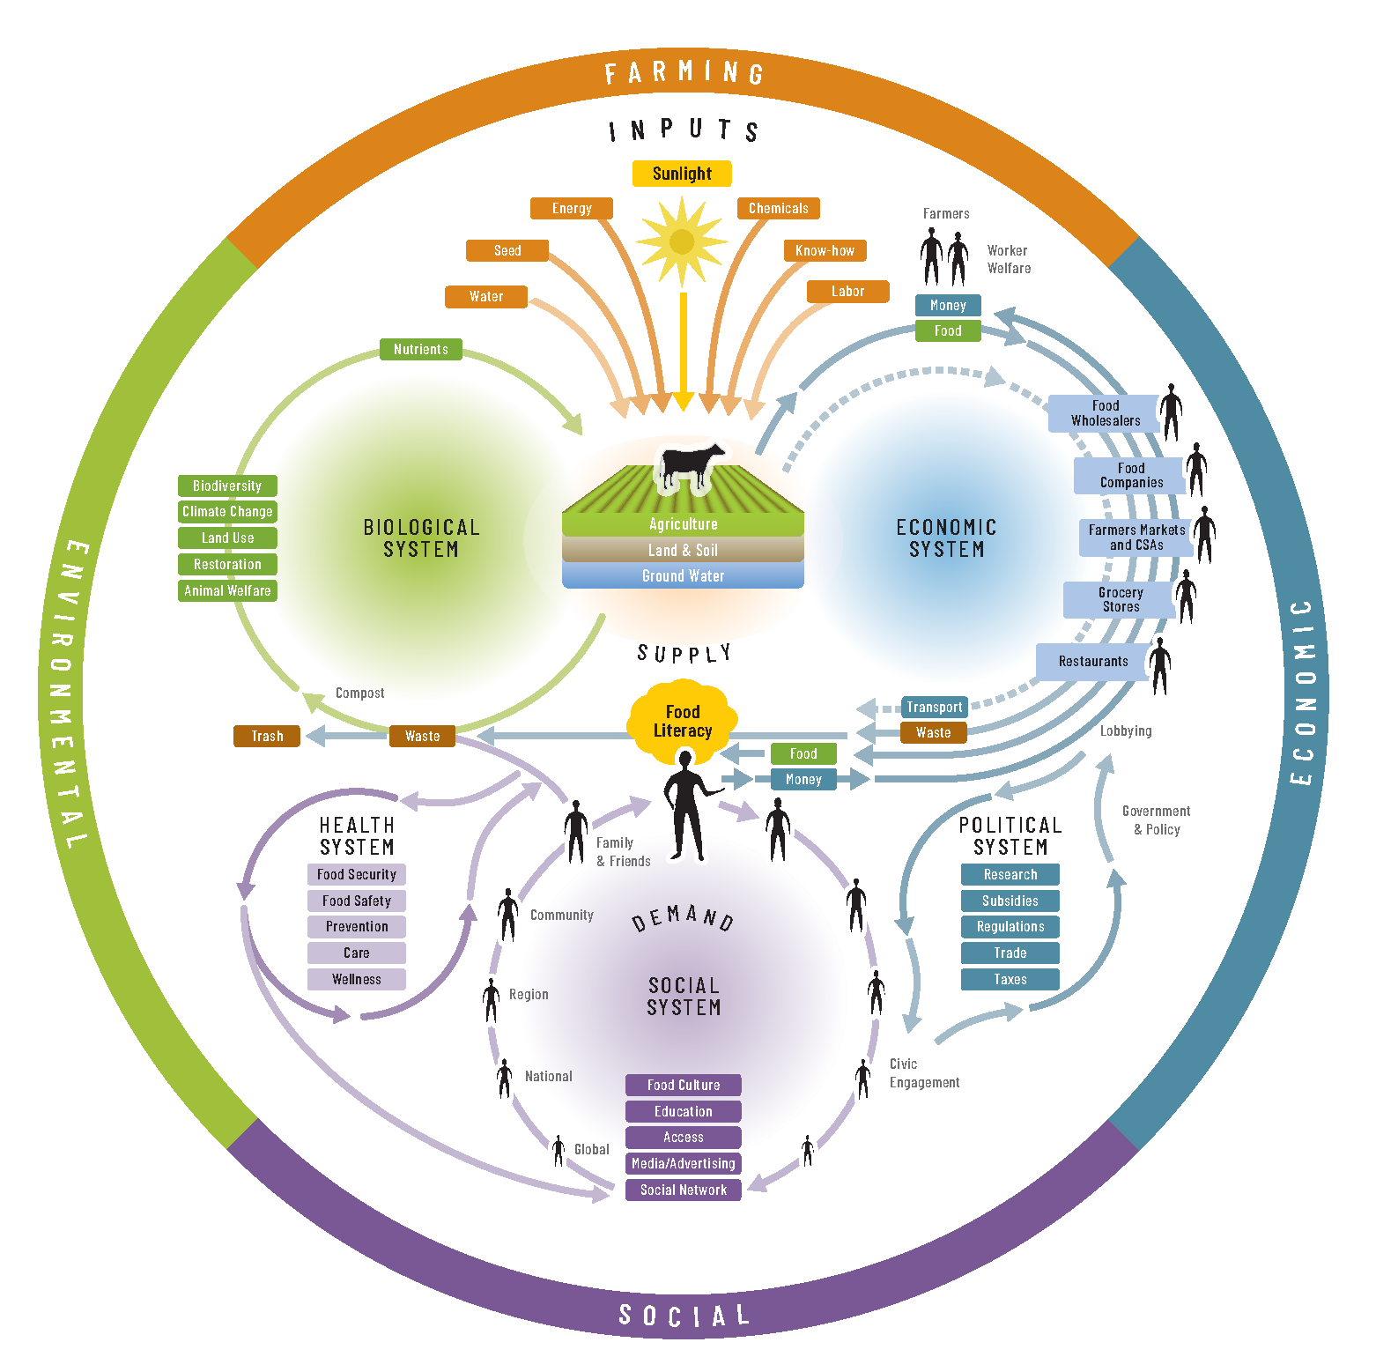
The ‘food system’ is everything that happens from farm to fork: the network of people, processes and interactions involved in growing, processing, distribution, sale and disposal of food on-farm, in retailing and at home. The urban environment has a significant effect on how people access food and what form this food takes (e.g. fresh, processed, packaged, etc) and therefore affects human and environmental health in many ways.
Figure 4
Source: Nourish Food System Map
As illustrated in the Nourish food system diagram (Figure 21), the food system is better understood not as a linear “supply chain” between farm to plate but a web of life that connects everything from soil microbes, plants and animals to energy consumption, retail environments, everyday food practices and food cultures of nourishment and celebration.

Urban food system
The urban food system describes the broader systems through which food moves and is accessed within a municipality. It encompasses a wide spectrum of products, actors, resources, networks and exchanges including economic infrastructure such as cafes, restaurants, supermarkets, greengrocers, food manufacturers and other retailers whose offerings include local and non-local products. The urban food system is affected by diverse social, environmental and economic forces, both positive and negative, including:
- geopolitical and other disruptions at the global level;
- dominant players influencing the food economy and shaping the interactions between urban and regional environments and communities;
- socio-economic inequality relating to employment, housing affordability and other forms of structural disadvantage;
- climate change and environmental conditions;
- the planning and design of urban environments, precincts and neighbourhoods;
- the social and cultural factors that influence how food provisioning, access; preparation and consumption of food; and
- the local, state and federal policy contexts which shape all of the above.
Together these factors determine the quality of food available within urban environments and whether that food is culturally appropriate, nutritionally adequate, affordable and safe.

Local food system
The local food system is connected to the peri-urban areas which are vital to the resilience and sustainability of the broader food system. It refers to the production of primary produce and processed goods within a municipality as well as community food networks organisations and leaders that advocate for and participate in how people interact with, access and consume food locally. It includes community food assets — productive spaces like backyards, community gardens and urban farms — as well as community kitchens, seed libraries and farmers markets. The alignment of the local food system to community values and aspirations is both enabled and constrained by the broader urban food context.

Local food
For the purposes of this strategy, local food includes food grown or processed within and around Banyule City Council, including in backyards, community gardens and urban farms. However it also includes Victorian produce and food products that are marketed, distributed and sold in farmers markets, local retailers or other social or economic systems that exist outside the mainstream supermarket sector.

Appendix C: Strategic context: policy analysis and mapping
Document | Strategic priorities | Alignment with Urban Food Strategy
Banyule Community Vision 2041 | Striving to achieve long-term social inclusion, economic prosperity and environmental sustainability, Council adopted the Banyule Community Vision 2041. The Banyule Community Vision 2041 includes 6 priority themes which outline the aspirations and focus of our community over the next 20 years.  1: Our Inclusive and Connected Community  2: Our Sustainable Environment  3: Our Well-Built City  4: Our Valued Community Assets and Facilities  5: Our Thriving Local Economy  6: Our Trusted and Responsive Leadership | Themes of the Community Vision are reflected throughout the urban food strategy.  Position Council to better respond to, and uplift adaptability and preparedness to, changing food consumption behaviours, urbanisation, climate change and other impacts on vulnerabilities experienced in local food systems  Supporting health and wellbeing, economic, environment development outcomes  Achieve food security and support urban food activities
Council Plan 2021-2025 | Key priorities for the current Council Plan are:  - Delivering opportunities and jobs for the Banyule community  - Powering local recovery – focus on local business and local jobs  - Delivering a sustainable future – zero waste to landfill by 2030  - Sound financial management  - Maintaining liveability  - Trusted leadership and governance – commitment to engage with the community at every opportunity  Key commitments:  1.2.9. Working with partners to take action on Banyule’s health priorities: social connection and inclusion; increasing active living; increasing healthy eating  2.5.1. Prepare to roll out a FOGO kerbside collection system to residents  2.8.1. Embed community gardens at Bellfield Community Centre  2.8.2. Develop a scope for an Urban Food Strategy  3.3. Prioritise a series of localised plans for 20-minute neighbourhoods across Banyule that are well connected and meeting community needs closer to home  5.1. Stimulate and support a vibrant and resilient local economy to encourage business, employment and investment opportunities  5.6. Provide and facilitate job readiness programs and pathways to employment.  5.6.1. Deliver a range of activities, programs or workshops that support young people’s employment pathways | Position Council to better respond to, and uplift adaptability and preparedness to, changing food consumption behaviours, urbanisation, climate change and other impacts on vulnerabilities experienced in local food systems  Supporting health and wellbeing, economic, environment development outcomes  Achieve food security and support urban food activities
Municipal Public Health and Wellbeing Plan 2021-2025 | Five key priorities:  - Gender equality and prevention of violence against women  - Tackling climate change and its impact on health  - Social inclusion and connection  - Increasing healthy eating  - Increasing active living | Position Council to better respond to, and uplift adaptability and preparedness to, changing food consumption behaviours, urbanisation, climate change and other impacts on vulnerabilities experienced in local food systems  Supporting health and wellbeing, economic, environment development outcomes
Community Climate Action Plan 2020 | Council is committed to more than 40 actions across eight themes, including:  - Whole of community engagement  - Circular economy  - Adaptation and resilience  Relevant actions and recommendations:  - Becoming a low carbon household: compost your own food / grow your own food / reduce your meat consumption  - Low carbon schools: local food production for schools / worm farms / increased biodiversity / Environmental grants programs e.g. Banyule Primary establishing worm farms / veggie garden / school chooks and food waste program  - Cafes and restaurants can compost waste by partnering with local community gardens’; and ‘purchase from local suppliers to the local economy and reduce emissions’  Circular Economy):  - Implement a FOGO system for the municipality  - Deliver a Buy Local campaign  - Continue and expand programs to increase awareness of food waste and local food production  - Enable composting at leased facilities  Note: Farmraiser case study | Position Council to better respond to, and uplift adaptability and preparedness to, changing food consumption behaviours, urbanisation, climate change and other impacts on vulnerabilities experienced in local food systems  Supporting health and wellbeing, economic, environment development outcomes  Achieve food security and support urban food activities  Opportunity / Action: Strong alignment with the goals of the Urban Food Strategy, with many synergies and areas of overlap / cross-referencing.
Towards Zero Waste Management Plan 2019-2023 | Vision: ‘a community motivated to achieve zero waste by 2030’.  Key priorities:  - Avoid waste generation’  - Build, support and strengthen a community culture that is striving to be zero waste  - Deliver environmentally responsible and cost-effective recycling and waste services  - Advocate to other levels of government to avoid waste, reduce waste to landfill and increase recycling  Big opportunity to reduce waste going to landfill will be with the introduction of FOGO, as 40% of waste going to landfill is food waste (2015 bin audit)  Actions include promotion of onsite at source green and food waste avoidance solutions to the community, including worm farms and compost bins | Position Council to better respond to, and uplift adaptability and preparedness to, changing food consumption behaviours, urbanisation, climate change and other impacts on vulnerabilities experienced in local food systems  Supporting health and wellbeing, economic, environment development outcomes  Achieve food security and support urban food activities  Opportunity / Action: Clear alignment with the goals of the Urban Food Strategy regarding promotion of composting, worm farming and food waste reduction at both household and business levels, as well as promoting better connectivity between hospitality businesses and community-led initiatives such as community gardens.
Partnership Framework / Neighbourhood House Strategy 2022 (draft) | The Partnership Framework consists of:  - The Collaboration Agreement  - An Annual Action Plan  - Funding Agreement  - Lease / Licensing Agreement  - Grant funding  Collaboration vision: Working together to build thriving, inclusive and connected communities in Banyule. Council’s role includes:  - Partnering with Neighbourhood Houses to develop and deliver projects and initiatives  - Providing financial support including annual operational funding to an agreed level and grant programs  The Neighbourhood Houses’ role includes:  - Participate in networking and partnership opportunities  - Partner to develop and delivery community development initiatives  - Respond to the needs of local communities  Council and the Neighbourhood Houses have a ‘shared commitment to strengthening the capacity of local communities’, underpinned by core principles for all parties. | Position Council to better respond to, and uplift adaptability and preparedness to, changing food consumption behaviours, urbanisation, climate change and other impacts on vulnerabilities experienced in local food systems  Supporting health and wellbeing, economic, environment development outcomes  Achieve food security and support urban food activities  Opportunity / Action: Neighbourhood Houses can play an important role in community food security projects and initiatives as well as community engagement and education regarding food growing, preparation, cooking and waste avoidance / reduction skills and practices. Neighbourhood Houses will be an important stakeholder in the processes to develop and implement the Urban Food Strategy.
Public Open Space Plan 2016-2031 | Relevant specific actions include:  - Develop strategies and on-going funding programs for open space facilities that provide greater diversity of opportunity e.g. environmental education trails, nature based play areas, community gardens, outdoor gym equipment etc.  - Identify sites where possible that aren’t considered ‘core’ open space e.g. power easements, for the development of specialised open space facilities, such as community gardens etc. | Supporting health and wellbeing, economic, environment development outcomes  Achieve food security and support urban food activities  Opportunity / Action: The emphasis on community gardens as open space will be important in incorporating opportunities to strengthen and (where possible) expand existing community gardens in Banyule as well as identify sites for potential new community gardens.
Banyule Social Infrastructure Framework 2022-2023 | Social infrastructure consists ‘of the facilities, spaces, networks and services that support individual and community health and wellbeing, promote a cohesive society and support economic prosperity’ (Australian Infrastructure Plan 2021)  Council has established the following benchmarks for physical infrastructure (i.e. community buildings):  - Fit for People  - Fit for Purpose  - Fit for Place  Council has established the following benchmarks for service infrastructure (i.e. services, programs and activities that support individuals and communities to achieve better health, wellbeing, social and economic outcomes):  - High quality  - Complementary  - Affordable  Relevant opportunities identified in the Framework include:  - Sports, recreation and leisure: pursue and reimagine high-capacity multipurpose spaces that support formal sports, active recreation and passive recreation activities; Upgrades to create accessible, affordable and sustainable facilities  - Social enterprise and job creation: Support evidence-based social enterprises to access tangible growth opportunities through planned capital works and support place-based approaches to employment and economic participation that will provide a pathway into a job; Use collaborative partnerships with suppliers to create employment and economic participation opportunities through the supply chain;  - Community partnerships: Planning and delivery of community hubs to pursue integrated or co-located service delivery, with a focus on addressing social infrastructure inequities and leveraging opportunities for better social, economic and environmental outcomes | Position Council to better respond to, and uplift adaptability and preparedness to, changing food consumption behaviours, urbanisation, climate change and other impacts on vulnerabilities experienced in local food systems  Supporting health and wellbeing, economic, environment development outcomes  Achieve food security and support urban food activities  Opportunity / Action: As with other Plans and Strategies, there are synergies with the development and implementation of the Urban Food Strategy, especially in terms of enhancing and expanding community access to spaces and places for food growing, food-related education and community connection around food (e.g. community kitchens and cooking classes, community compost hubs, etc.)
Social Enterprise Action Plan 2020-2025 | The Social Enterprise Action Plan has four focus areas:  - Advance place-based social enterprise innovation  - Build business capability and capacity  - Improve market access  - Increase community awareness and engagement | Position Council to better respond to, and uplift adaptability and preparedness to, changing food consumption behaviours, urbanisation, climate change and other impacts on vulnerabilities experienced in local food systems  Supporting health and wellbeing, economic, environment development outcomes  Achieve food security and support urban food activities  Opportunity / Action: Food- and farm-based social enterprises are a rapidly emerging sector of the urban food system in Australia and internationally. Business models for urban farm and food social enterprises include direct marketing of produce, urban agritourism / farm tours, school excursions and outdoor learning opportunities, community workshops, therapeutic horticulture, youth traineeships, certificate programs and much more. At the same time, as the Action Plan acknowledges, social enterprises (especially start ups) need various forms of support and nurturing in order to succeed.
Inclusive Local Jobs Strategy 2020-  2025 | The Inclusive Local Jobs Strategy ‘addresses inequalities of access to employment and aims to build opportunity and economic prosperity for local people experiencing barriers to employment’. The Strategy’s adoption recognises entrenched disadvantage for ‘vulnerable community groups underrepresented in the labour market’. The goals are to:  - Stimulate inclusive employment opportunities  - Strengthen pathways to employment  - Grow business and entrepreneurship  - Advance inclusive employment practices across the local government and private sector  Building on the success of creating 102 local jobs via place-based community and economic development through the Social Enterprise and Local Jobs unit, this Strategy supports Council’s aspirational target of creating 1000 local jobs for local people experiencing barriers to employment by 2025. | Position Council to support Banyule urban farms and food social enterprises, as well as allied initiatives emerging through the La Trobe NEIC, to create employment pathways for vulnerable community members.  Opportunity / Action: Build on the pioneering work of Farmraiser and Veggie Empire to explore opportunities to expand their capacity for inclusive local jobs. Explore opportunities for a similar collaboration at Rosanna Primary School, and conduct an audit of Melbourne Water and other land to scope further urban farm opportunities.
Neighbourhood Character Strategy | The Neighbourhood Character Strategy assesses the existing residential neighbourhoods and preparing preferred  character statements that outline whether it is the existing character that should be respected, or a defined  preferred new character.  Neighbourhood Character Strategy should:  • Identify the significance of each neighbourhood area  • Identify key issues and threats to neighbourhood character  • Provide strategic direction for neighbourhood character to guide future development  • Form the basis for any variations to the Planning Scheme, such as policies or objectives for neighbourhood  character or changes to a residential zone schedule.  • Demonstrate that housing objectives will not be prejudiced when deciding on how neighbourhood character will be protected.  • Draw on community views | The Neighbourhood Character Strategy pertains primarily to residential areas. However economic homogeneity in food shops diminishes neighbourhood character by reducing diversity and creating a sameness across the economic landscape.  The local food environment could also be considered part of what gives a neighbourhood its distinctive quality.
Urban Forest Strategy 2022-2032 (draft) | The Urban Forest Strategy recognises the ‘vital contribution that the [150,000 trees] of the Banyule Urban Forest provides for biodiversity and habitat as well as neighbourhood character and designed amenity’. The Strategy articulates the role of council and community as custodians of this critical element of Banyule’s natural environment. The draft Strategy is grounded in five key principles of custodianship, partnership, planning and stewardship, and sets out six strategic focus areas:  - Prioritise urban forest improvements in the most vulnerable suburbs and places across Banyule  - Increase the diversity of the Urban Forest for biodiversity and habitat with ground cover and shrub layer plantings  - Manage the Urban Forest across public and private land for resilience to climate change  - Take a long term, asset management approach to the Urban Forest  - Build and maintain partnerships with others in the protection and management of the Urban Forest  - Integrate urban forest principles across Council services | The focus of the Urban Forest Strategy is to enhance neighbourhood amenity, preserve and enhance Banyule’s Urban Forest to meet the challenges and climate change and to support urban biodiversity, prioritising the most vulnerable suburbs; and foster a partnership approach to Urban Forest stewardship.  It is clear that a percentage of the existing Urban Forest will contain edible species (e.g. olive trees, stone fruit trees); and that in expanding the Urban Forest Banyule will have the opportunity to align actions and targets under this Strategy with all key themes of the Urban Food Strategy, in particular Creating Abundant Edible Landscapes and Planning for Healthy and Sustainable Food Environments. An expanded and well-managed Urban Forest that includes many edible species offers considerable potential to contribute to the goal of dignified food security for all Banyule residents.
Community Infrastructure  Plan 2023-2033 (draft) | The Community Infrastructure Plan is focused on Council-owned community infrastructure with the following objectives:  - Resources are directed where they best meet the needs of our growing and changing community.  - Consistent decision-making approach across Council in relation to planning, management and funding of community infrastructure.  - Address demand for community infrastructure fairly and equitably using an evidence-based approach.  - Maximise the use and performance of existing infrastructure to meet current and future community needs.  - Identify collaborative partnerships with government, organisations and the private sector to attract investment in new and existing infrastructure.  - Identify investment priorities for the next 10 years. | This Plan has potential alignment with key themes of the Urban Food Strategy, in particular Creating Abundant Edible Landscapes and Planning for Healthy and Sustainable Food Environments. In the first instance an audit of existing community infrastructure could be undertaken with a view to considering potential food-growing and / or community food-related uses (e.g. community kitchens), consistent with the vision and priorities of the Urban Food Strategy.
Economic Development Strategy 2023-2028 Background Report | The key pillars of Banyule’s economy are health, knowledge-intensive industries, industrial and population-serving.  This Report noted the following macroeconomic trends:  - COVID-19 business recovery and remote working  - Workforce/skills shortages in key sectors - hospitality, construction, childcare, community and aged care  - Environmental sustainability and circular economy  - Transition of retail with the increase in online shopping  - Growing demand for healthcare  The Report places importance on growing Banyule’s visitor economy ‘as it stimulates business investment, promotes local consumption and supports new local jobs’. While the existing visitor economy is small the Report notes opportunities for growth, including by enhancing the local events calendar.  A key opportunity provided by the La Trobe National Employment and Innovation Cluster (NEIC) is ‘the region’s economic focal point supported by a network of vibrant and attractive activity centres.’ The La Trobe NEIC will include the creation of ‘thousands of jobs in the food and beverage industry, agriculture and food science’, as well as manufacturing, health and logistics industries.  Key recommendations:  - Growth is supported through business partnerships and regional collaborations. New start-ups are nurtured while existing businesses continue to be supported to grow and be successful  - There is a range of local employment opportunities for all  - Innovation and technological advances are embraced, and social enterprises are well established  - The municipality has substantial education and job training opportunities for people of all ages and abilities, and provide a range of career opportunities, particularly for young people and those returning to the workforce  - Volunteerism is encouraged and promoted as a valuable contributor to the community and local economy  The Report notes that ‘retail centres and strips are increasingly adopting a place-based approach to expand the role of strips to include civic and recreational destinations for communities.’ | Position Council to better respond to, and uplift adaptability and preparedness to, changing food consumption behaviours, urbanisation, climate change and other impacts on vulnerabilities experienced in local food systems  Supporting health and wellbeing, economic, environment development outcomes  Achieve food security and support urban food activities  Opportunity / Action: The emphasis on place-making, sustainability, local jobs and the circular economy creates strong synergies with multi-functional urban food systems, enterprises and community-led initiatives. Imaginative urban design and planning that could incorporate edible streetscapes (e.g. with rooftop and vertical gardens) would enhance the aesthetics of the existing activity centres and built form, supporting the visitor economy focus, as well as making these places more welcoming and inclusive for local community members.  Industry and employment analysis reveals that agriculture, forestry and fishing declined by 23% in the period 2015-2020, accommodation and food services declined by 7%, and retail trade by 8% over the same period. Nevertheless, food retailing remains a significant sub-sector of the Banyule economy, employing 1,571 people and generating output of $140 mn in 2020. See the Key Findings section of this report for a discussion about the implications of these trends.

Appendix D: Urban Food Strategy Working Group
Terms of Reference
Supporting the participatory and inclusive development of an Urban Food Strategy for Banyule City Council, with the medium and long-term goals of increasing:
- access to culturally appropriate and local food,
- community knowledge and skills related to healthy and sustainable food,
- urban food system resilience and food security, and
- climate change adaptation to reduce the impacts of climate change on health and wellbeing
The creation of the Urban Food Strategy is the first step in an ongoing process of food system change and strengthening. The quality and nature of the implementation of the Strategy’s action plan will ultimately determine what change takes place, the degree of inclusiveness of that change, and its impact on the health and wellbeing of the most disadvantaged Banyule residents, as well as the impact on the sustainability, resilience and integrity of the urban food system.
Objectives
The Working Group objectives are as follows:

- Ensure the principles of inclusion, equity, access and participation are embedded in the Urban Food Strategy development process through representation of Banyule’s diverse communities and food system stakeholders, especially those who may be vulnerable.
- Create and nurture an ethos of collaboration and shared responsibility from the outset of the process, with community and council building a shared agenda and vision together.
- Build and strengthen community capacity and leadership.
- Guide the process of strategy development through advice and support to the project team.
- Build collective and mutually reinforcing activities with a focus on the successful development of the Urban Food Strategy and aligned projects, strategies and initiatives.
- Facilitate continuous communication amongst members and project partners.
- Identify shared resources within, and external to the Working Group and project team that align with the project’s objectives.
- Lay the foundations for a Banyule Urban Food Network that can provide ongoing guidance and momentum in the implementation and monitoring phases of the Urban Food Strategy following its endorsement.
Governance Structure
The Banyule Urban Food Strategy Working Group is the advisory arm to the project team. All discussions and meetings of the Banyule are within the parameters of the Urban Food Strategy development objectives and will be consistent with the collective impact approach.

Membership of the Working Group
Members of the Working Group have been approached individually by Banyule City Council and have indicated their willingness to participate in this forum. Representation is sought from organisations involved in food systems and youth services-related activities in the two municipalities mentioned. The membership will not exceed fourteen (14) persons.
Meetings of the Working Group
The Working Group, in consultation and support from the project team, will meet in order to support the objectives of the Urban Food Strategy development and the Working Group objectives as set out above. Four meetings will be held during the course of development of the Strategy, with two in 2022 and two in the first four months of 2023. Meetings are anticipated to last for 60-90 minutes.
Chairperson
Appointed by the Working Group
Minute Taker/Agenda
Project team
Decisions
The role of the Urban Food Strategy Working Group is to provide guidance and support to the project team. The project team has primary responsibility for strategic project decision making. The Working Group members will first reach decisions through consensus. When voting is required a majority vote will apply with the chair having the deciding vote. A quorum is present when five (5) members are present.
Monitoring / Review /Accountability / Reporting
The Working Group will review its role at the conclusion of an initial term of six months. These Terms of Reference will be reviewed at that six-month period.
Behavioural Expectations
Working Group members can expect:
● An environment where their knowledge and expertise is respected
● To be kept informed
● To be consulted
● To have equal say
● To have any concerns heard and taken seriously
● To actively contribute and be acknowledged for their contribution

References
Abley, S., Cassar, O., Khinsoe, E., Marks, L., Vanderzwan, O., Palermo, C. & Kleve, S. (2020). Do Farmers’ Markets Offer Consumers an Available and Affordable Supply of Fresh Fruit and Vegetables Compared to Other Retail Outlets in Australia? Journal of Hunger & Environmental Nutrition, 15(6), 827–834.
Australian Bureau of Statistics. (2016). Census of Population and Housing: Socio-Economic Indexes for Areas (SEIFA), Australia, 2016.
Barbour, L., Lindberg, R., Woods, J., Charlton, K., & Brimblecombe, J. (2022). Local urban government policies to facilitate healthy and environmentally sustainable diet-related practices: a scoping review. Public health nutrition, 25(2), 471-487.
Bowden, M. (2020). Understanding food insecurity in Australia. Australian Institute of Family Studies.
Carey, R., Murphy, M., & Alexandra, L. (2021). COVID-19 highlights the need to plan for healthy, equitable and resilient food systems. Cities & health, 5(sup1), S123-S126.
Carrad, A., Aguirre-Bielschowsky, I., Reeve, B., Rose, N., Charlton, K. (2022a). Australian local government policies on creating a healthy, sustain-able, and equitable food system: Analysis in New South Wales and Victoria. Australian and New Zealand Journal of Public Health, 46(3), 332–339.
Carrad, A., Turner, L., Rose, N., Charlton, K., Reeve, B. (2022b). The role of Australian local governments in creating a healthy, sustainable, and equitable food system: Discussion themes from the workshop, ‘Healthy, sustainable, equitable food systems: The role of local government’. University of Sydney.
Coulson, H., & Sonnino, R. (2019). Re-scaling the politics of food: Place-based urban food governance in the UK. Geoforum, 98, 170-179.
Davies, S. (2018). Engaging with local authorities: stories, challenges and tips from the Sustainable Food Places Network. Food Matters, UK Soil Association and Sustain UK.
Department of Land, Environment, Water and Planning (2019). 20-Minute Neighbourhoods: Creating a more Liveable Melbourne. State Government of Victoria.
Donati, K., & Rose, N. (2020). Every seed I plant is a wish for tomorrow: Findings and Action Agenda from the 2020 National Pandemic Gardening Survey. Sustain: the Australian Food Network.
Donati, K. and Rose, N. (2022). Growing Edible Cities and Towns: A Survey of the Victorian Urban Agriculture Sector. Sustain: the Australian Food Network.
FoodBank Australia (2022). FoodBank Hunger Report 2022.
Gichunge, C., Somerset, S., & Harris, N. (2016). Using a household food inventory to assess the availability of traditional vegetables among resettled African refugees. International Journal of Environmental Research and Public Health, 13(1), 137.
Kavian, F., Mehta, K., Willis, E., Mwanri, L., Ward, P. & Booth, S. (2020). Migration, stress and the challenges of accessing food: an exploratory study of the experience of recent Afghan women refugees in Adelaide, Australia. International Journal of Environmental Research and Public Health, 17(4), 1379.
Laznik, N., Shahid, M., Dunford, E., Coyle, D., Taylor, F., and Jones, A. (2021). FoodSwitch: State of the Food Supply - Australia. George Institute of Global Health.
Lee, A. J., Cullerton, K., & Herron, L. M. (2021). Achieving food system transformation: insights from a retrospective review of nutrition policy (in) action in high-income countries. International Journal of Health Policy and Management, 10(Special Issue on Political Economy of Food Systems), 766-783.
Leeuwis, C., Boogaard, B. K., & Atta-Krah, K. (2021). How food systems change (or not): Governance implications for system transformation processes. Food Security, 13(4), 761-780.
Needham, C., Strugnell, C., Allender, S. & Orellana, L. (2022). Beyond food swamps and food deserts: exploring urban Australian food retail environment typologies. Public Health Nutrition 25(5),1140-115.
Rose, N. & Lourival, I. (2019). Hegemony, counter-hegemony and food systems literacy: transforming the global industrial food system. Australian Journal of Environmental Education, 35(2), 110-122.
Sheridan, J., Carey, R., & Candy, S. (2016). Melbourne's foodprint: what does it take to feed a city?.
Sibbing, L. V., Duncan, J., Arcuri, S., Galli, F., & Bock, B. B. (2022). Assessing what food policies lead to on the ground: exploring opportunities and challenges of the MUFPP indicator framework. Agroecology and Sustainable Food Systems, 46(9), 1414-1439.
Slade, C. & Baldwin, C. (2017). Critiquing Food Security Inter‐governmental Partnership Approaches in Victoria, Australia. Australian Journal of Public Administration, 76(2), 204-220.
Smith, K. & Lawrence, G. (2018). From disaster management to adaptive governance? Governance challenges to achieving resilient food systems in Australia. Journal of Environmental Policy & Planning, 20(3), 387-401.
Swinburn, B., Kraak, V., Rutter, H., Vandevijvere, S., Lobstein, T., Sacks, G., Gomes, F., Marsh, T. & Magnusson, R. (2015). Strengthening of accountability systems to create healthy food environments and reduce global obesity. The Lancet, 385(9986), 2534-2545.
Thackaway, W. and Randolph, B. (2021, September). Housing, financial stress and electoral geography: an analysis of the spatial distribution of housing-associated financial stress. City Futures Research Centre, University of New South Wales.
World Wildlife Fund (2021, February 25). ‘How recyclable are your favourite food products?’.

See The Year of the Rate Hike: Where will interest go in 2023?
The Henderson poverty line, updated quarterly by the Melbourne Institute, was developed by the Commission of Inquiry into Poverty chaired by Ronald Henderson, which delivered a major report Poverty in Australia in August 1975. It set a line for an ‘austere’ standard of living, accounting for a range of basic household needs, beneath which a household was deemed to be living in poverty. The Henderson poverty line is between 25%-33% higher than the Relative Poverty Line (calculated as a percentage of the population earning less compared to the median wage of the working population).
Respondents identifying as First Nation, LGBTIQA+ communities and disabled were disproportionately food-insecure, though extremely small sample sizes for these population groups means caution must be used in generalising the findings.
For the purposes of this report, “food economy” refers to agriculture, food manufacturing, food retailing, grocer/liquor/tobacco wholesaling and food and beverage services. Industry data regarding the food economy includes the following industry sub-sectors: forestry support services and liquor/tobacco wholesaling.
Unhealthy food environments include fast food chains, independent fast food retailers, takeaway food outlets (takeaway is the primary offering or where the outlet specialises in one type of unhealthy food such as pizza or fish and chips), sweets/confectionery and convenience stores. Food businesses were identified via Council’s food business register and classified by food outlet type. In some cases, businesses were reclassified due to inconsistencies in the original dataset. For example, Some McDonalds outlets were classified as ‘family restaurant’ rather than ‘fast food chain’.
The ABS SEIFA Index of Relative Socio-economic Disadvantage (2016) is a general socio-economic index that summarises a range of information about the economic and social conditions of people and households within an area.
https://localfoodconnect.org.au/elthamfm/cost-comparisons/
Demographic datasets include Banyule community and economic profiles (.idCommunity), Victorian Council of Social Service Poverty Maps, Department of Social Services JobSeeker and Youth Allowance recipients figures and the Everybody’s Home financial stress map for Victoria (2021).

